Q1)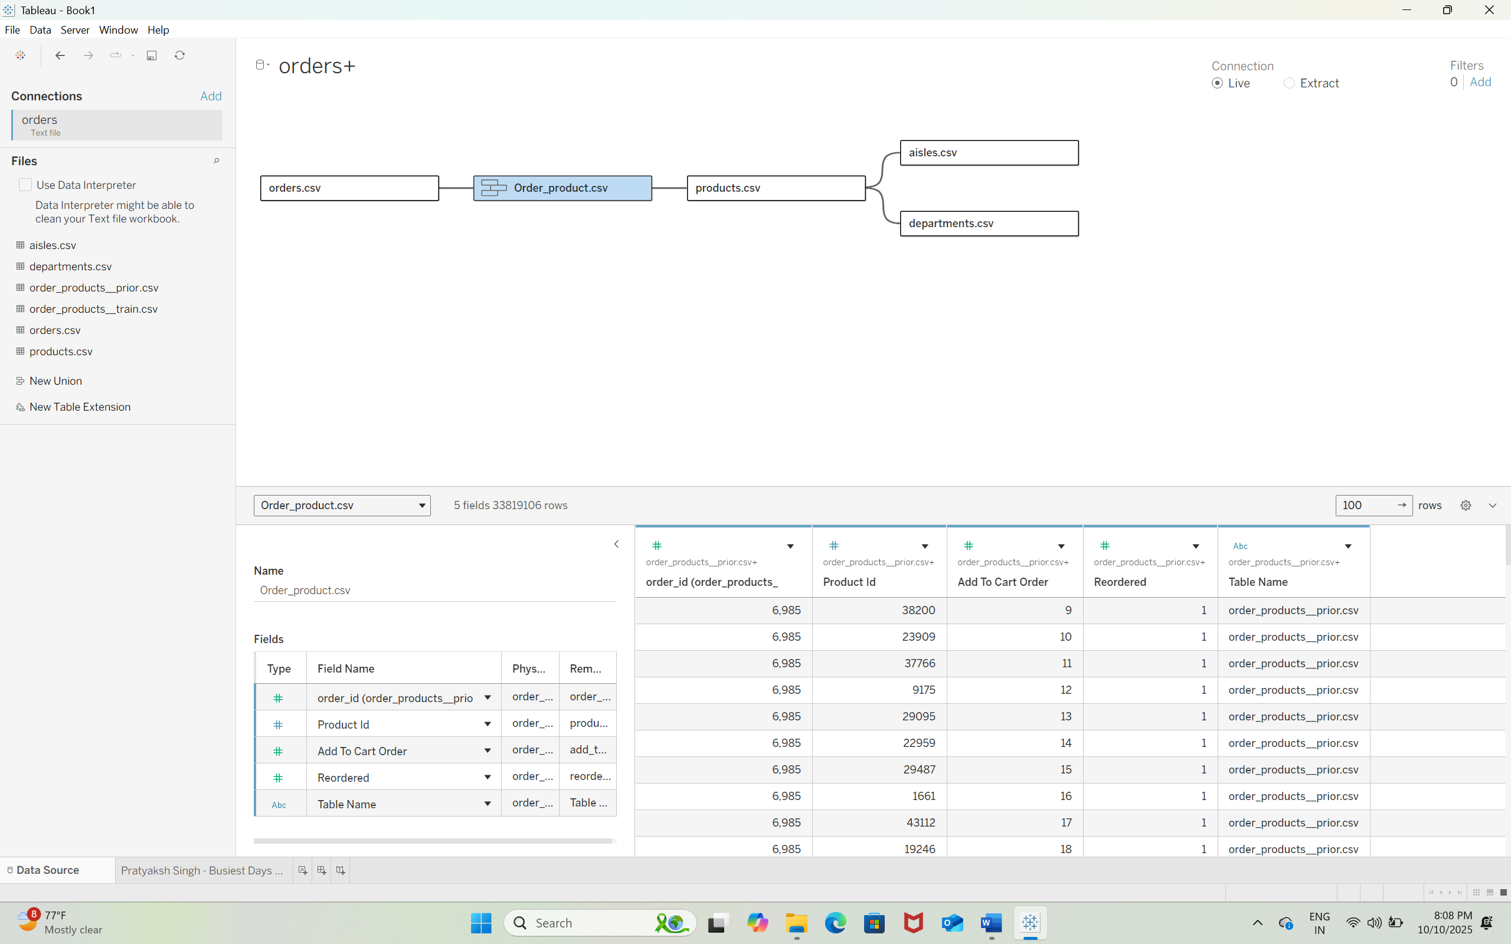  
Q2) Merchandising & Category Teams – Need insights into top-performing categories and products (produce, dairy, snacks) to fine-tune stocking levels and promotional focus.  
Operations & Logistics – Must anticipate peak times (late mornings, early afternoons, weekends) to optimize staffing schedules and inventory replenishment.  
Marketing & Consumer Insights – Leverage purchase patterns by time of day (e.g., breakfast vs. evening snacking) for targeted, high-impact campaigns aimed at increasing basket size.

Q3)  
The Chief Operations Officer (COO) serves as the primary decision maker for strategic calls on staffing optimization, promotional investment, and product mix expansion.  
Q5)  
Narrow focus – Designed specifically for internal leadership in merchandising, operations, and marketing who are directly responsible for translating insights into actionable plans, rather than for external stakeholders.  
Q6) Operational Performance – Reduce stock shortages and streamline service during peak volumes.  
Revenue Growth – Keep popular items well-stocked and strategically promoted to maximize sales.  
Strategic Marketing – Align promotions with high-traffic time segments to boost engagement and conversion.  
Q7)  
Optimize Staffing & Replenishment – Boost workforce allocation for peak hours and maintain strong stock levels of high-demand items.  
Deploy Timed Promotions – Offer specific deals, such as “Morning Specials” or “Weekend Rush Bundles,” tied to customer purchase patterns.  
Refine Targeting – Use reorder and time-based behavior to craft highly relevant marketing campaigns.  
Q8) Revenue Risk – Stockouts during high demand can push customers toward competitors.

Customer Loyalty – Fast service and consistent availability foster repeat business.

Competitive Edge – Data-backed adjustments reinforce trust and brand strength.  
Q9) The data reveals that fresh produce, especially fruits, is a major sales driver, with demand peaking in late mornings and early afternoons on weekends. By aligning staffing, stocking, and promotions with these patterns, the business can elevate efficiency, enhance the customer journey, and grow profitability. The core idea is to harness data to cut through distractions and zero in on high-impact opportunities for operational and marketing success.

Q)10  
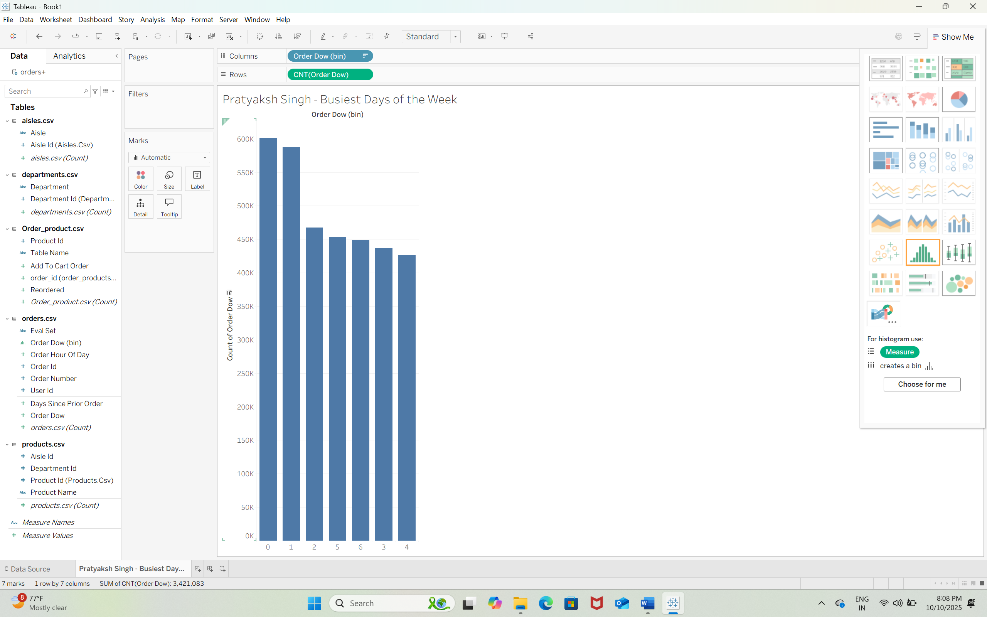  
Q11) Saturday and Sunday are two busiest days of the week.  
  
Q12)  
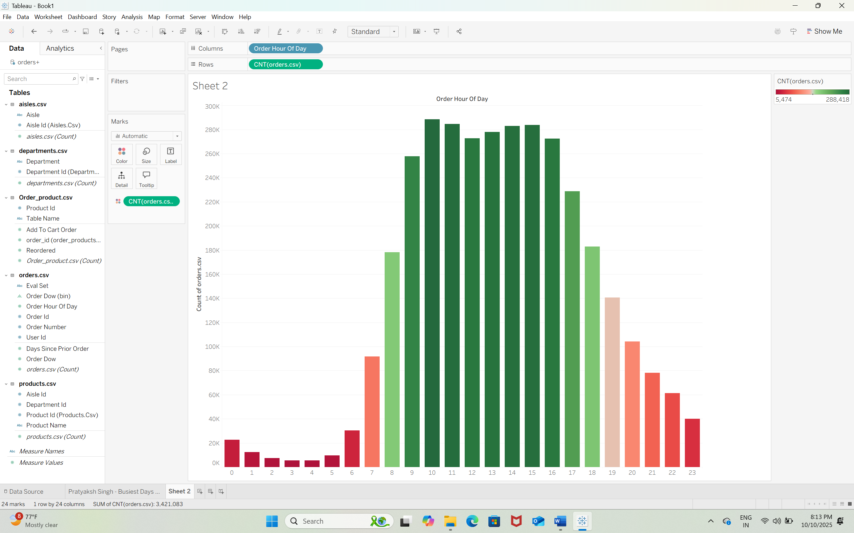  
  
Q13) The Top 11 busiest hours are 8,9,10,11,12,13,14,15,16,17,18.  
Q14)  
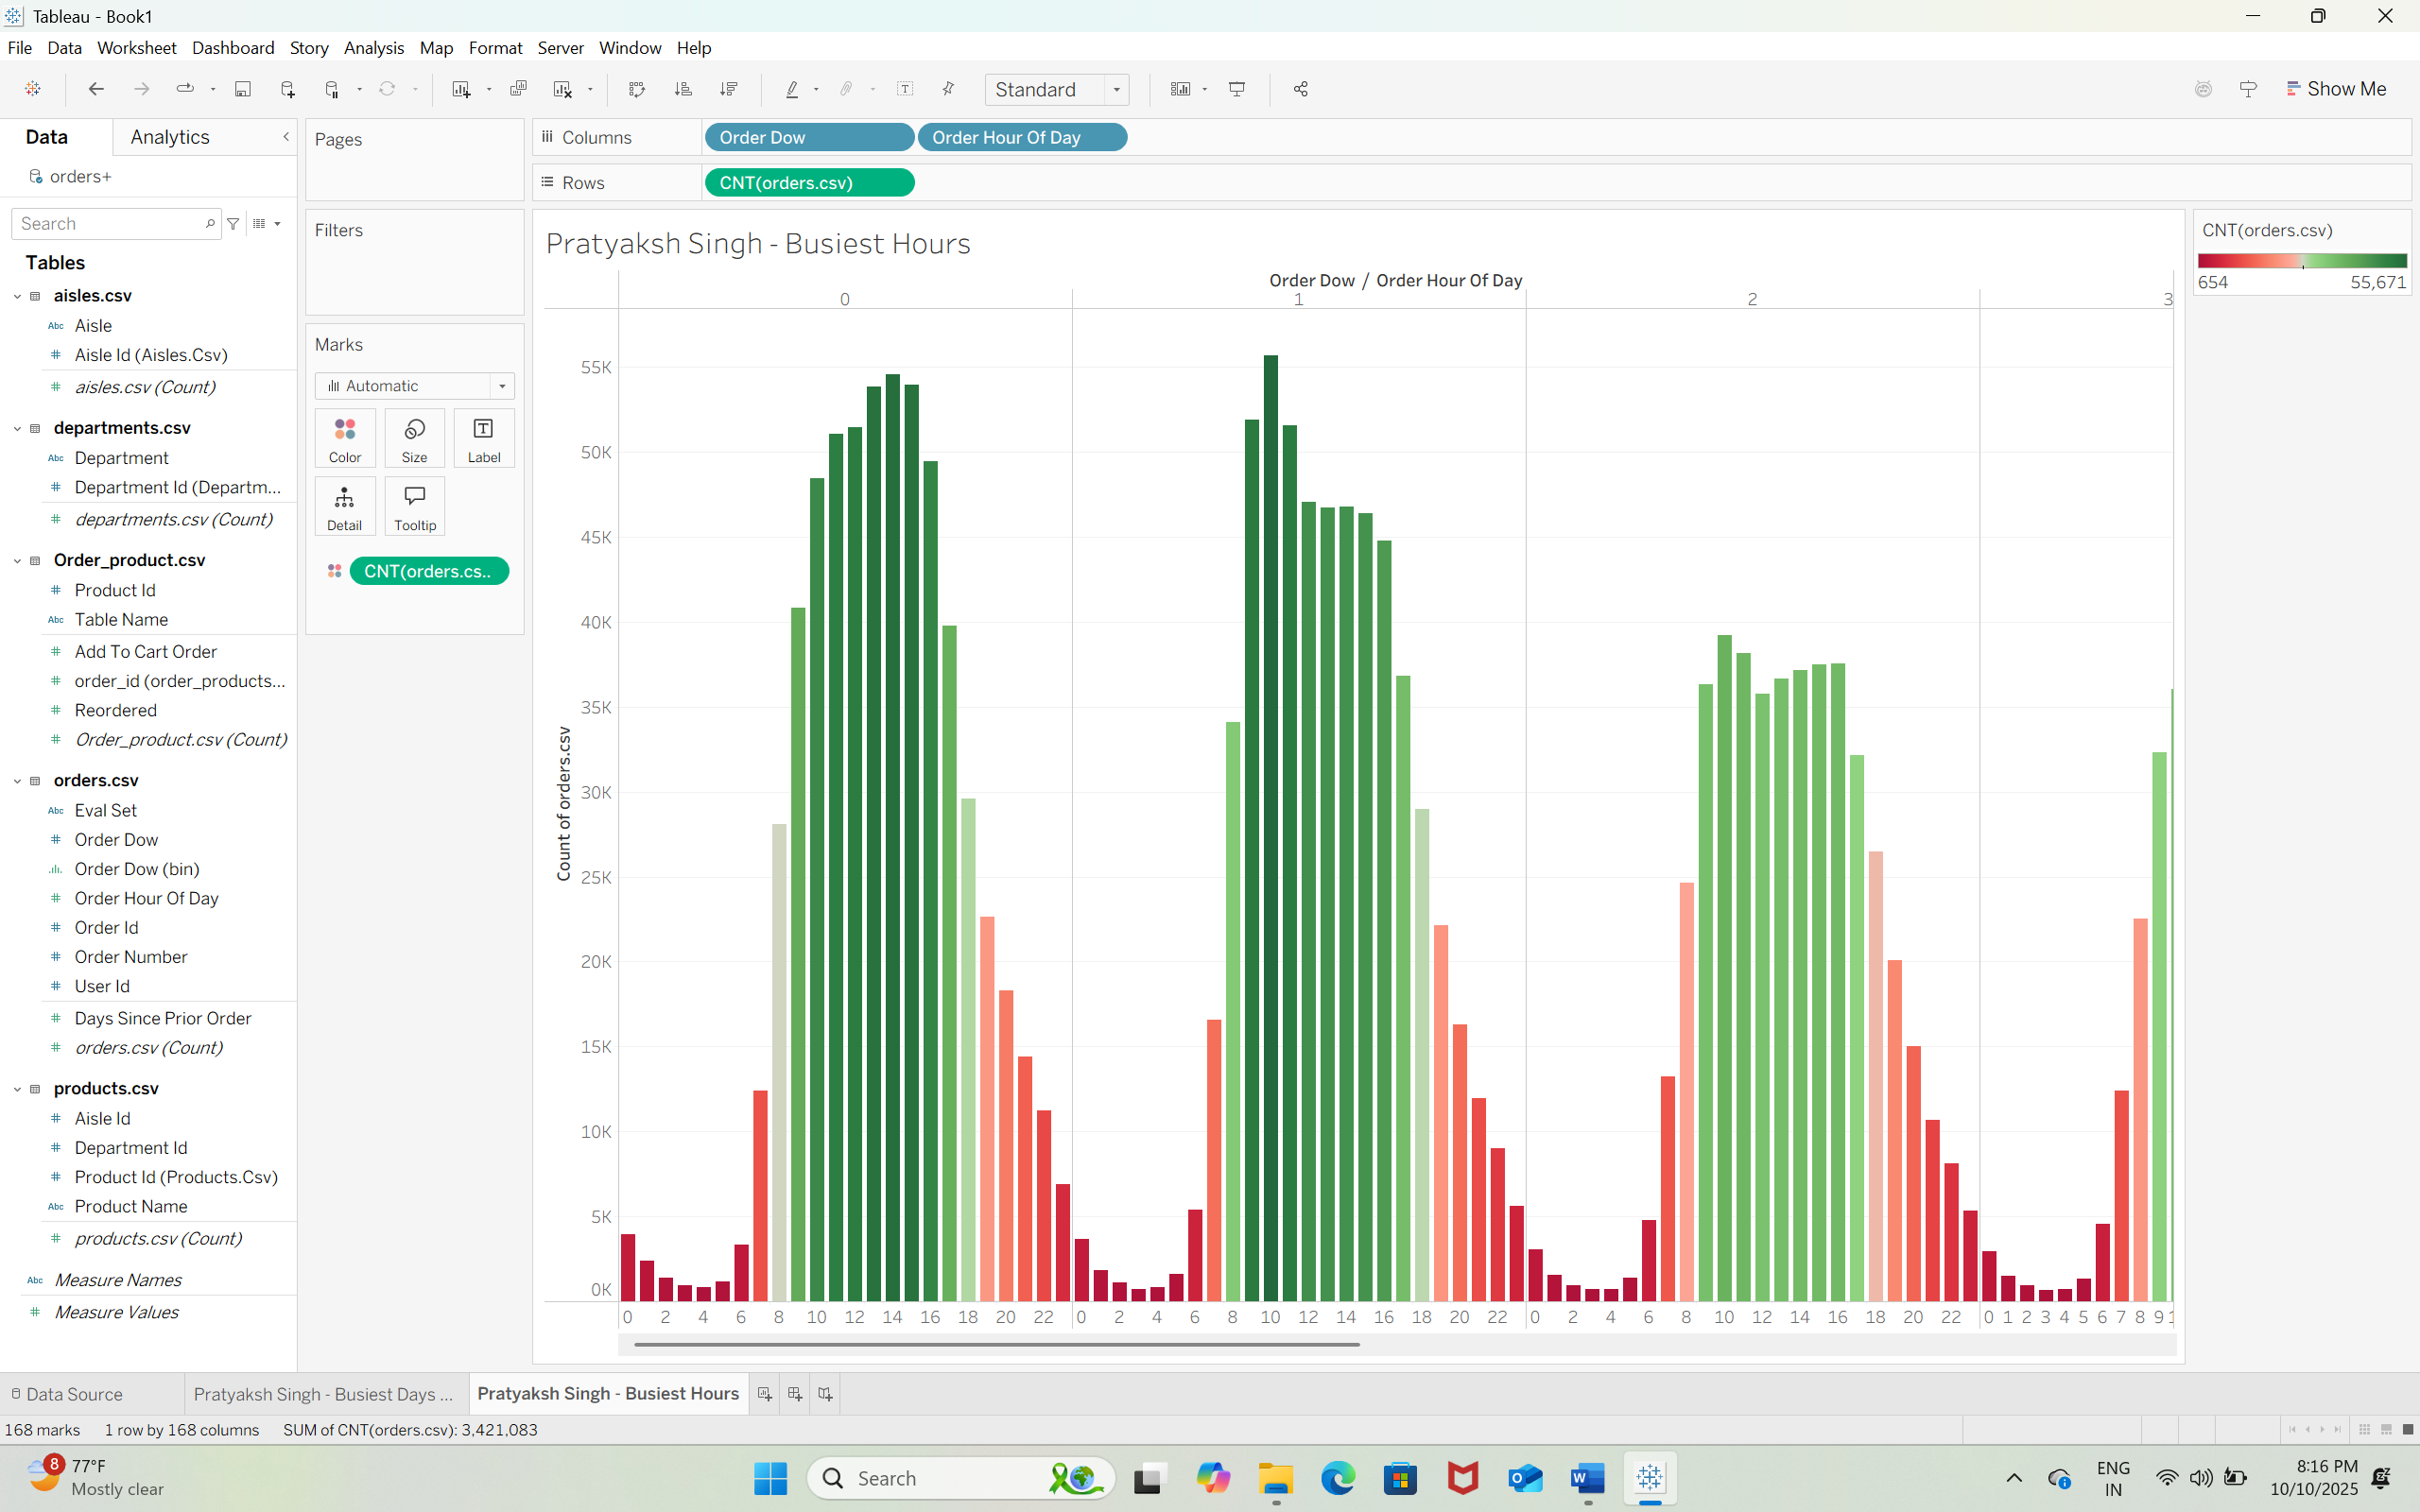  
  
Q15)

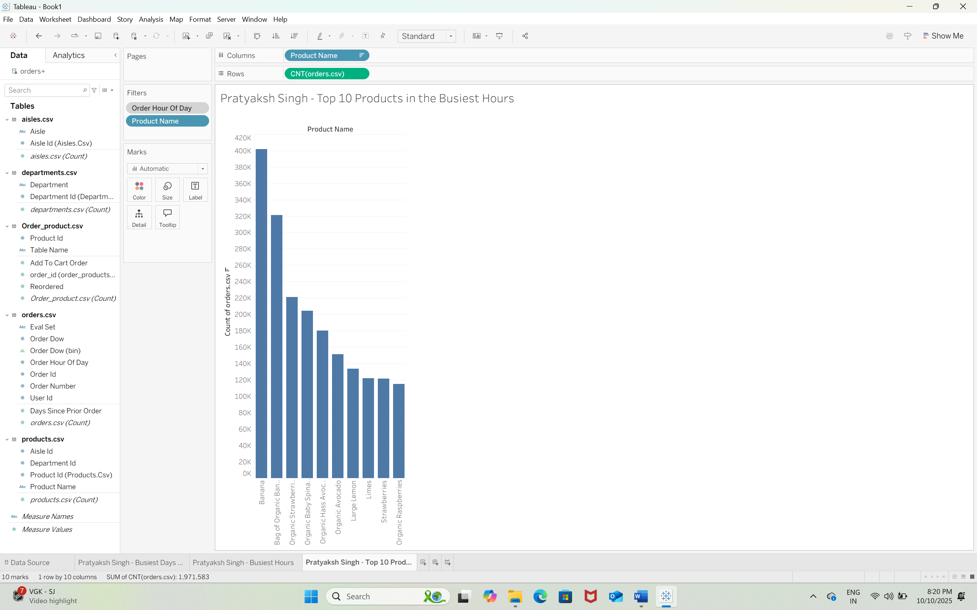  
  
Q16) The Banana is the most sold product in the busiest hours.  
Q17)

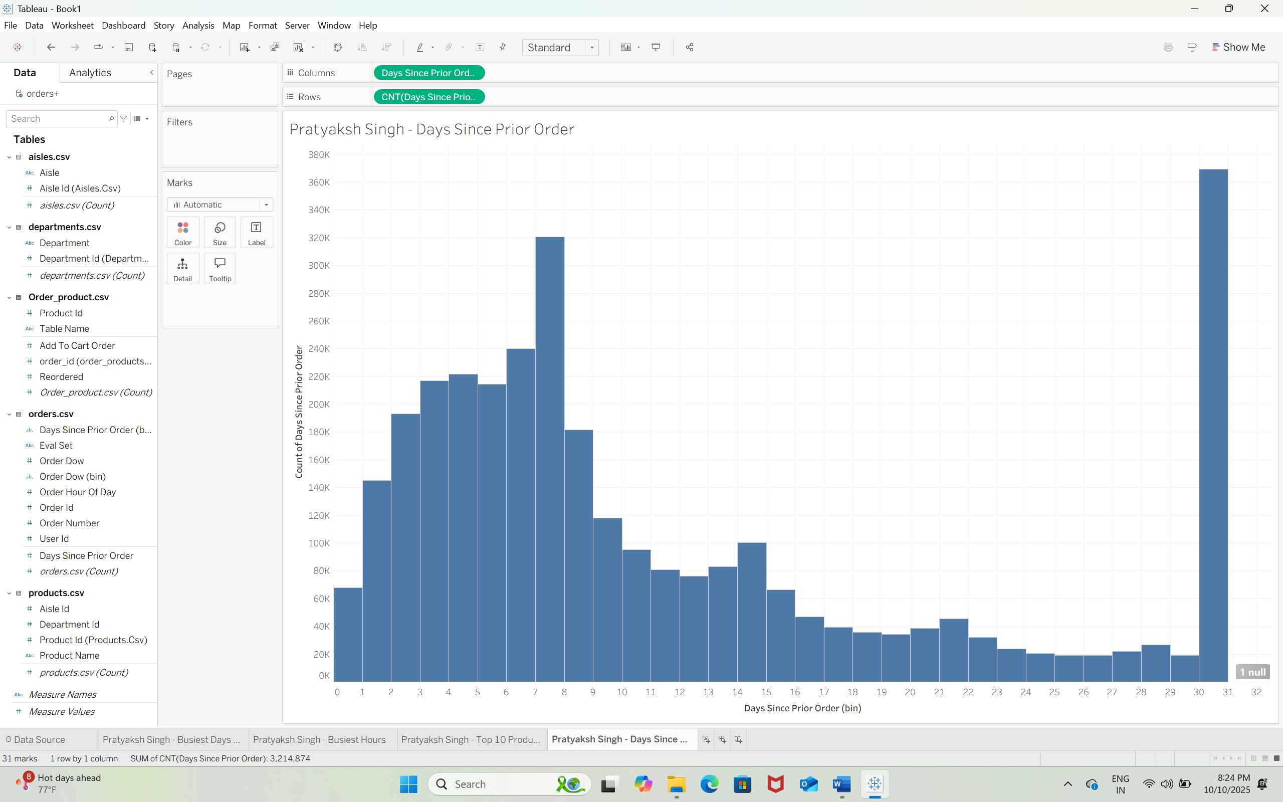  
Q18) Customers tend to reorder weekly (around 7 days) and monthly (around 30 days).  
  
Q19)   
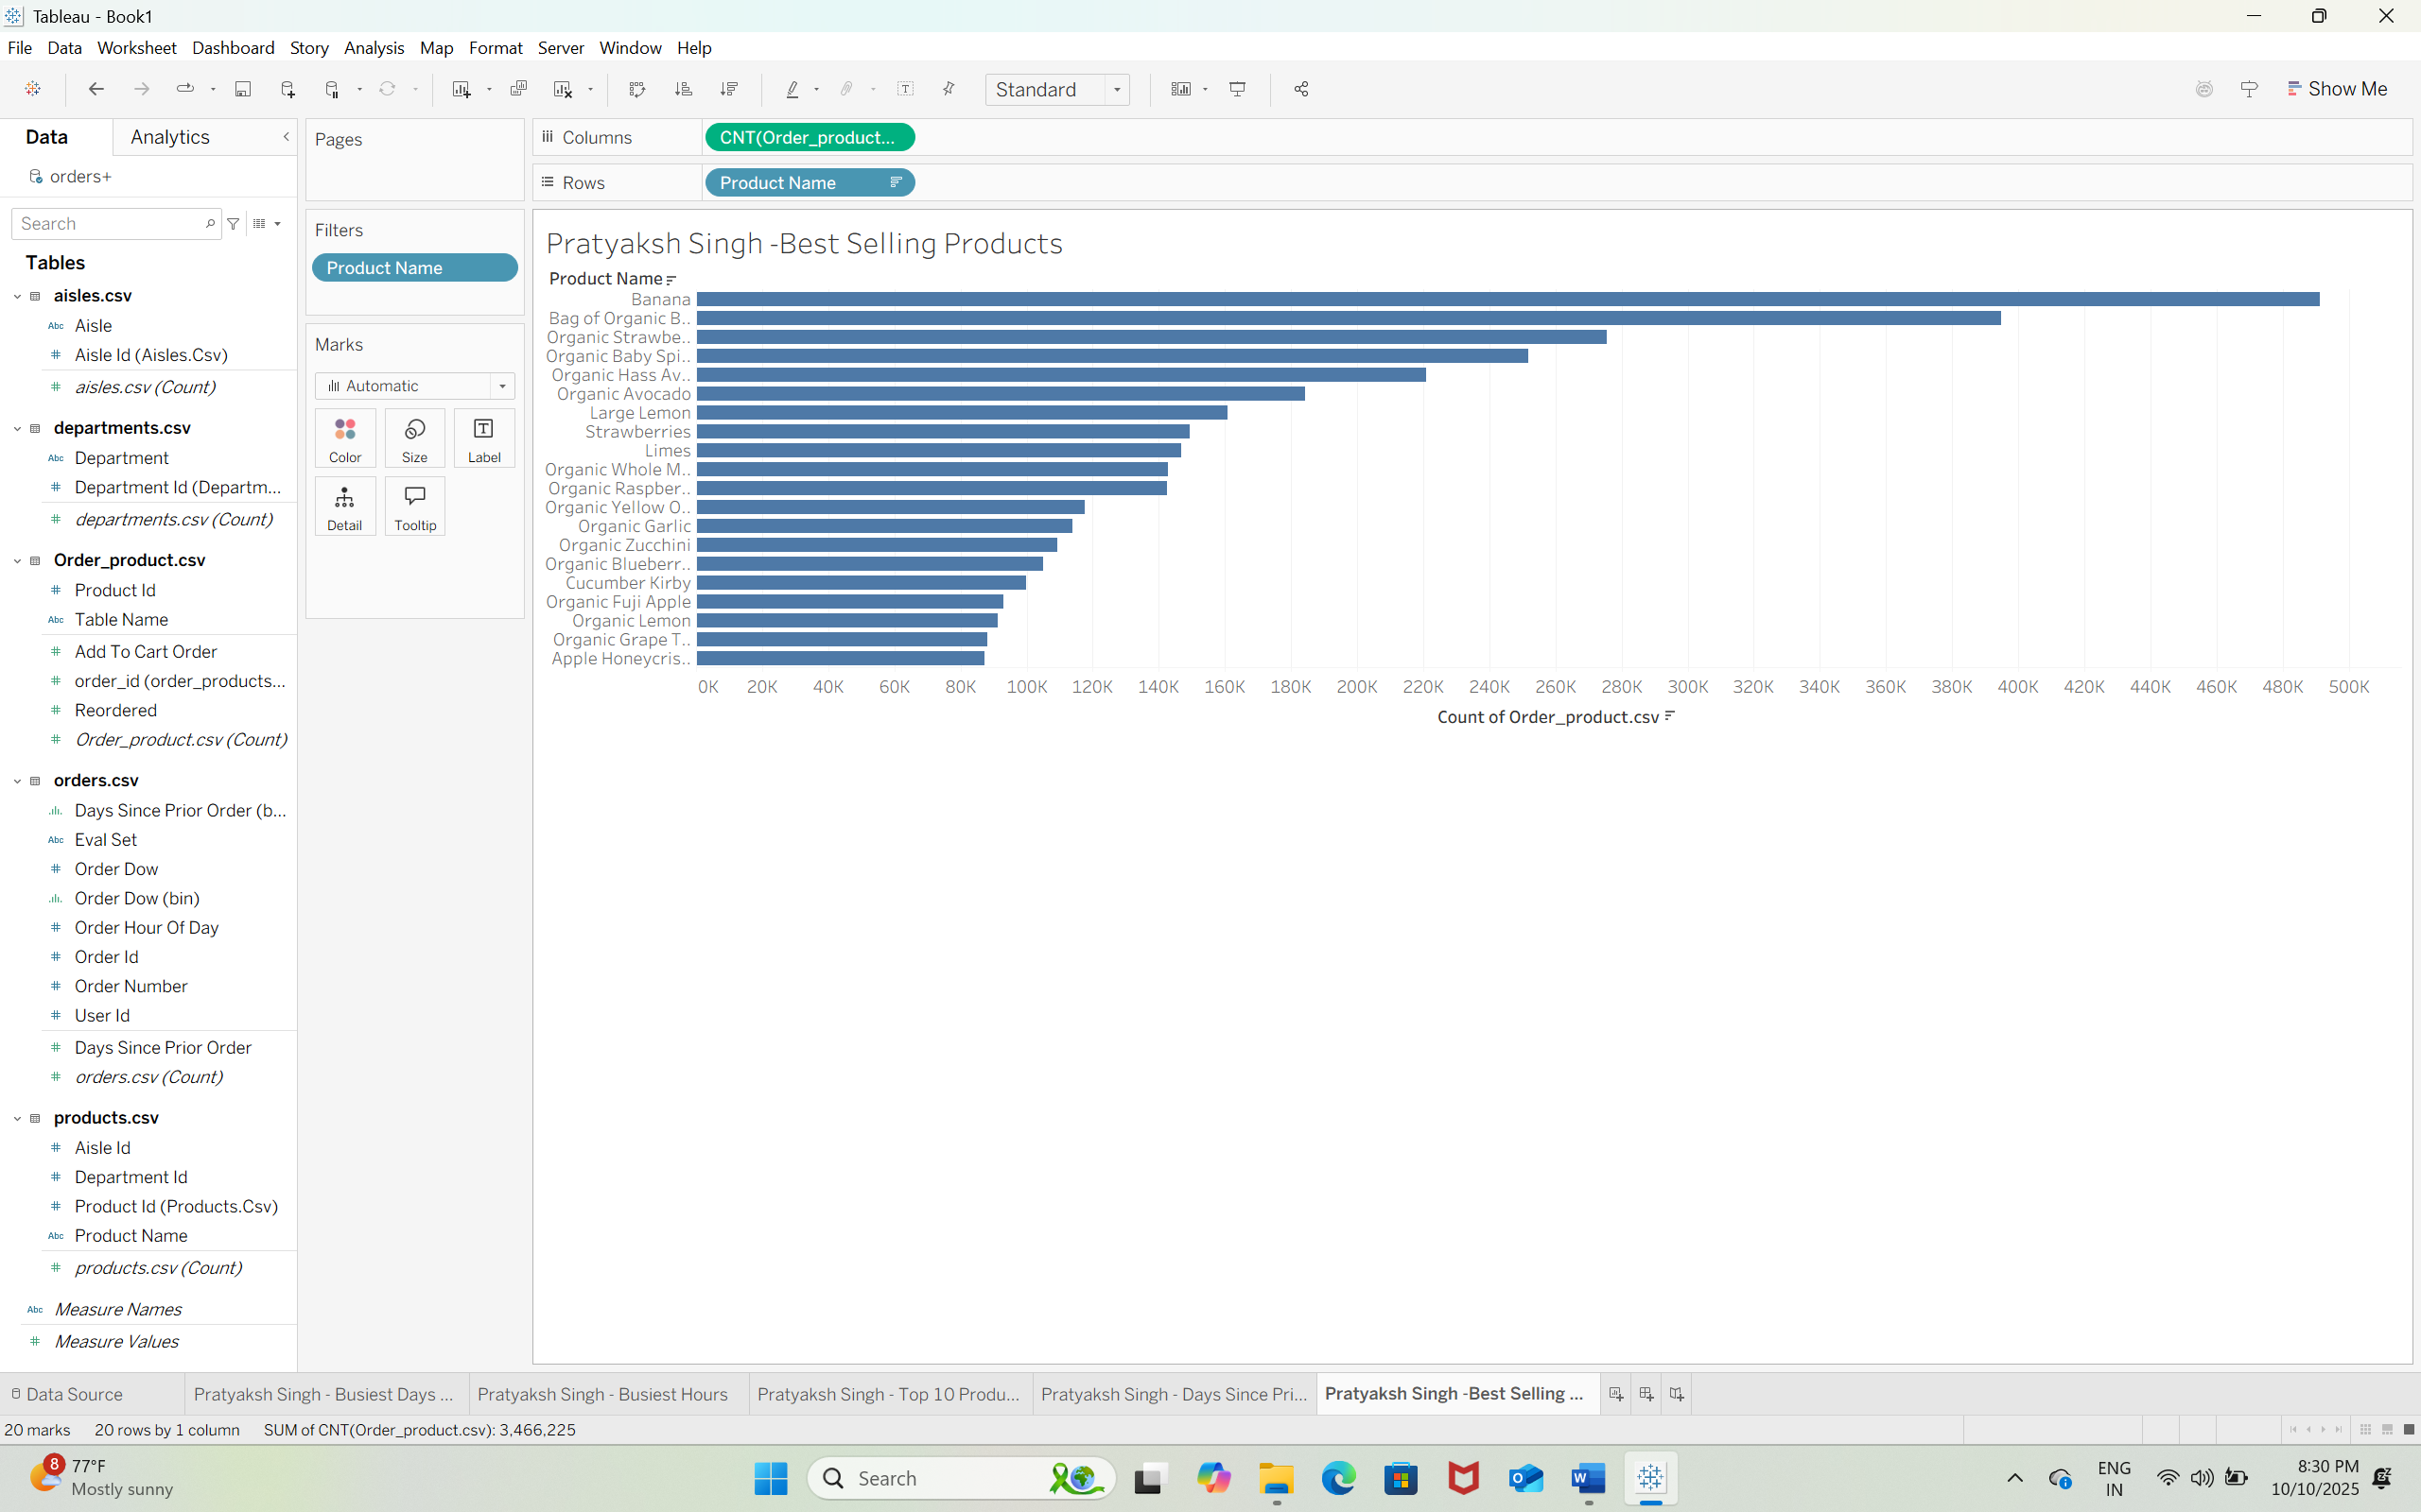  
  
Q20) Top 3 Best-selling products are – Banana, Bag of Organic Bananas & Organic Strawberries.  
Q21)   
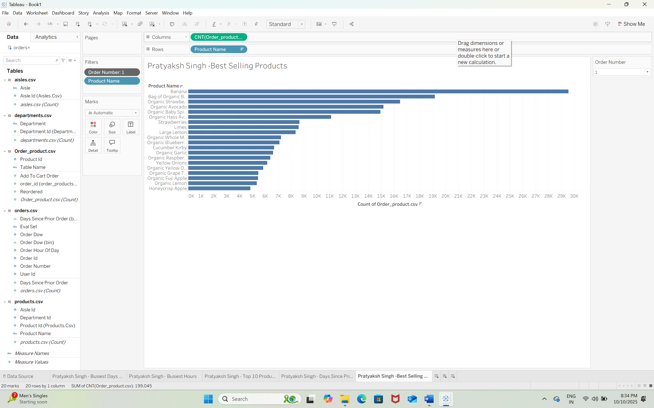  
  
Q22)  
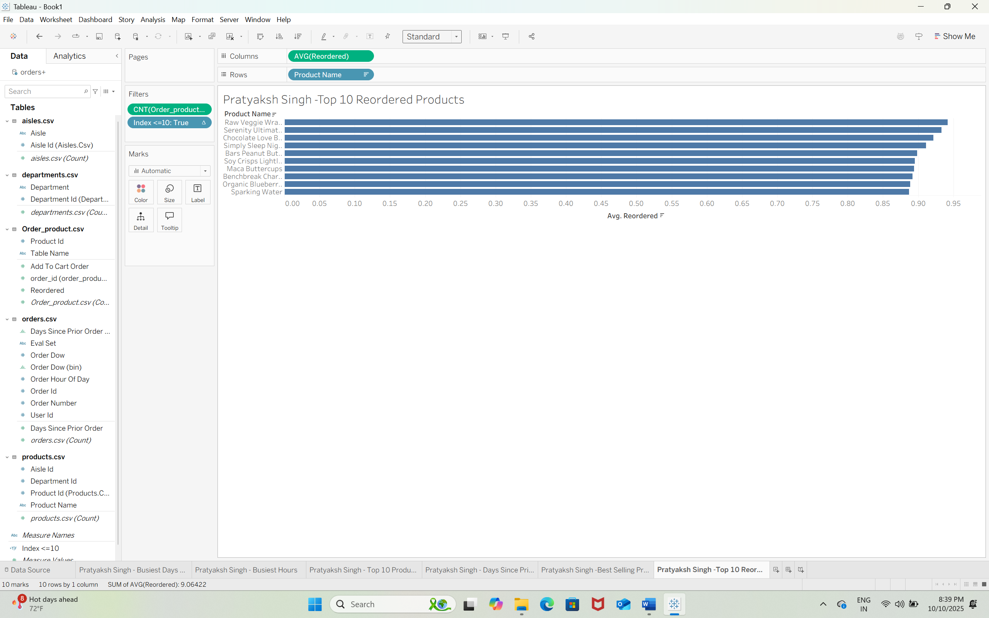  
  
Q23) Raw Veggie Wrappers is the most reordered product. Reorder probability is approximately 0.94(94%).  
Q24)  
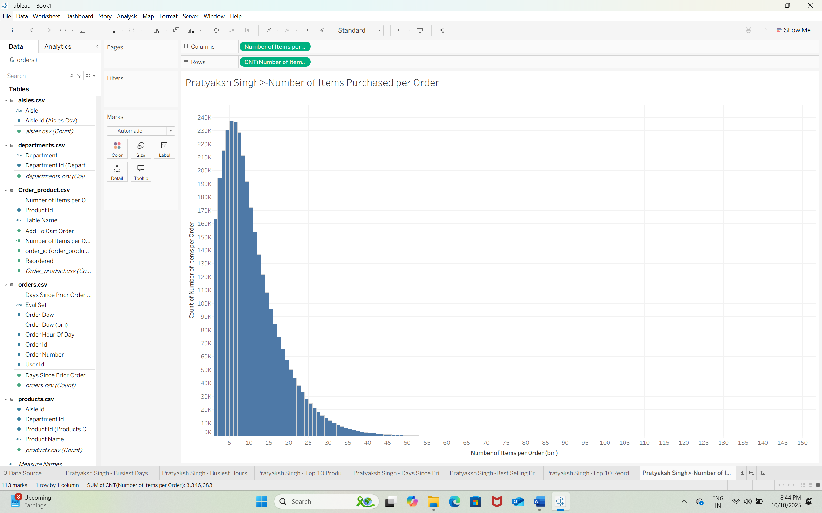  
  
Q25) Customers most often order around 3 to 8 items per order, as indicated by the highest frequency in the histogram.  
Q26)   
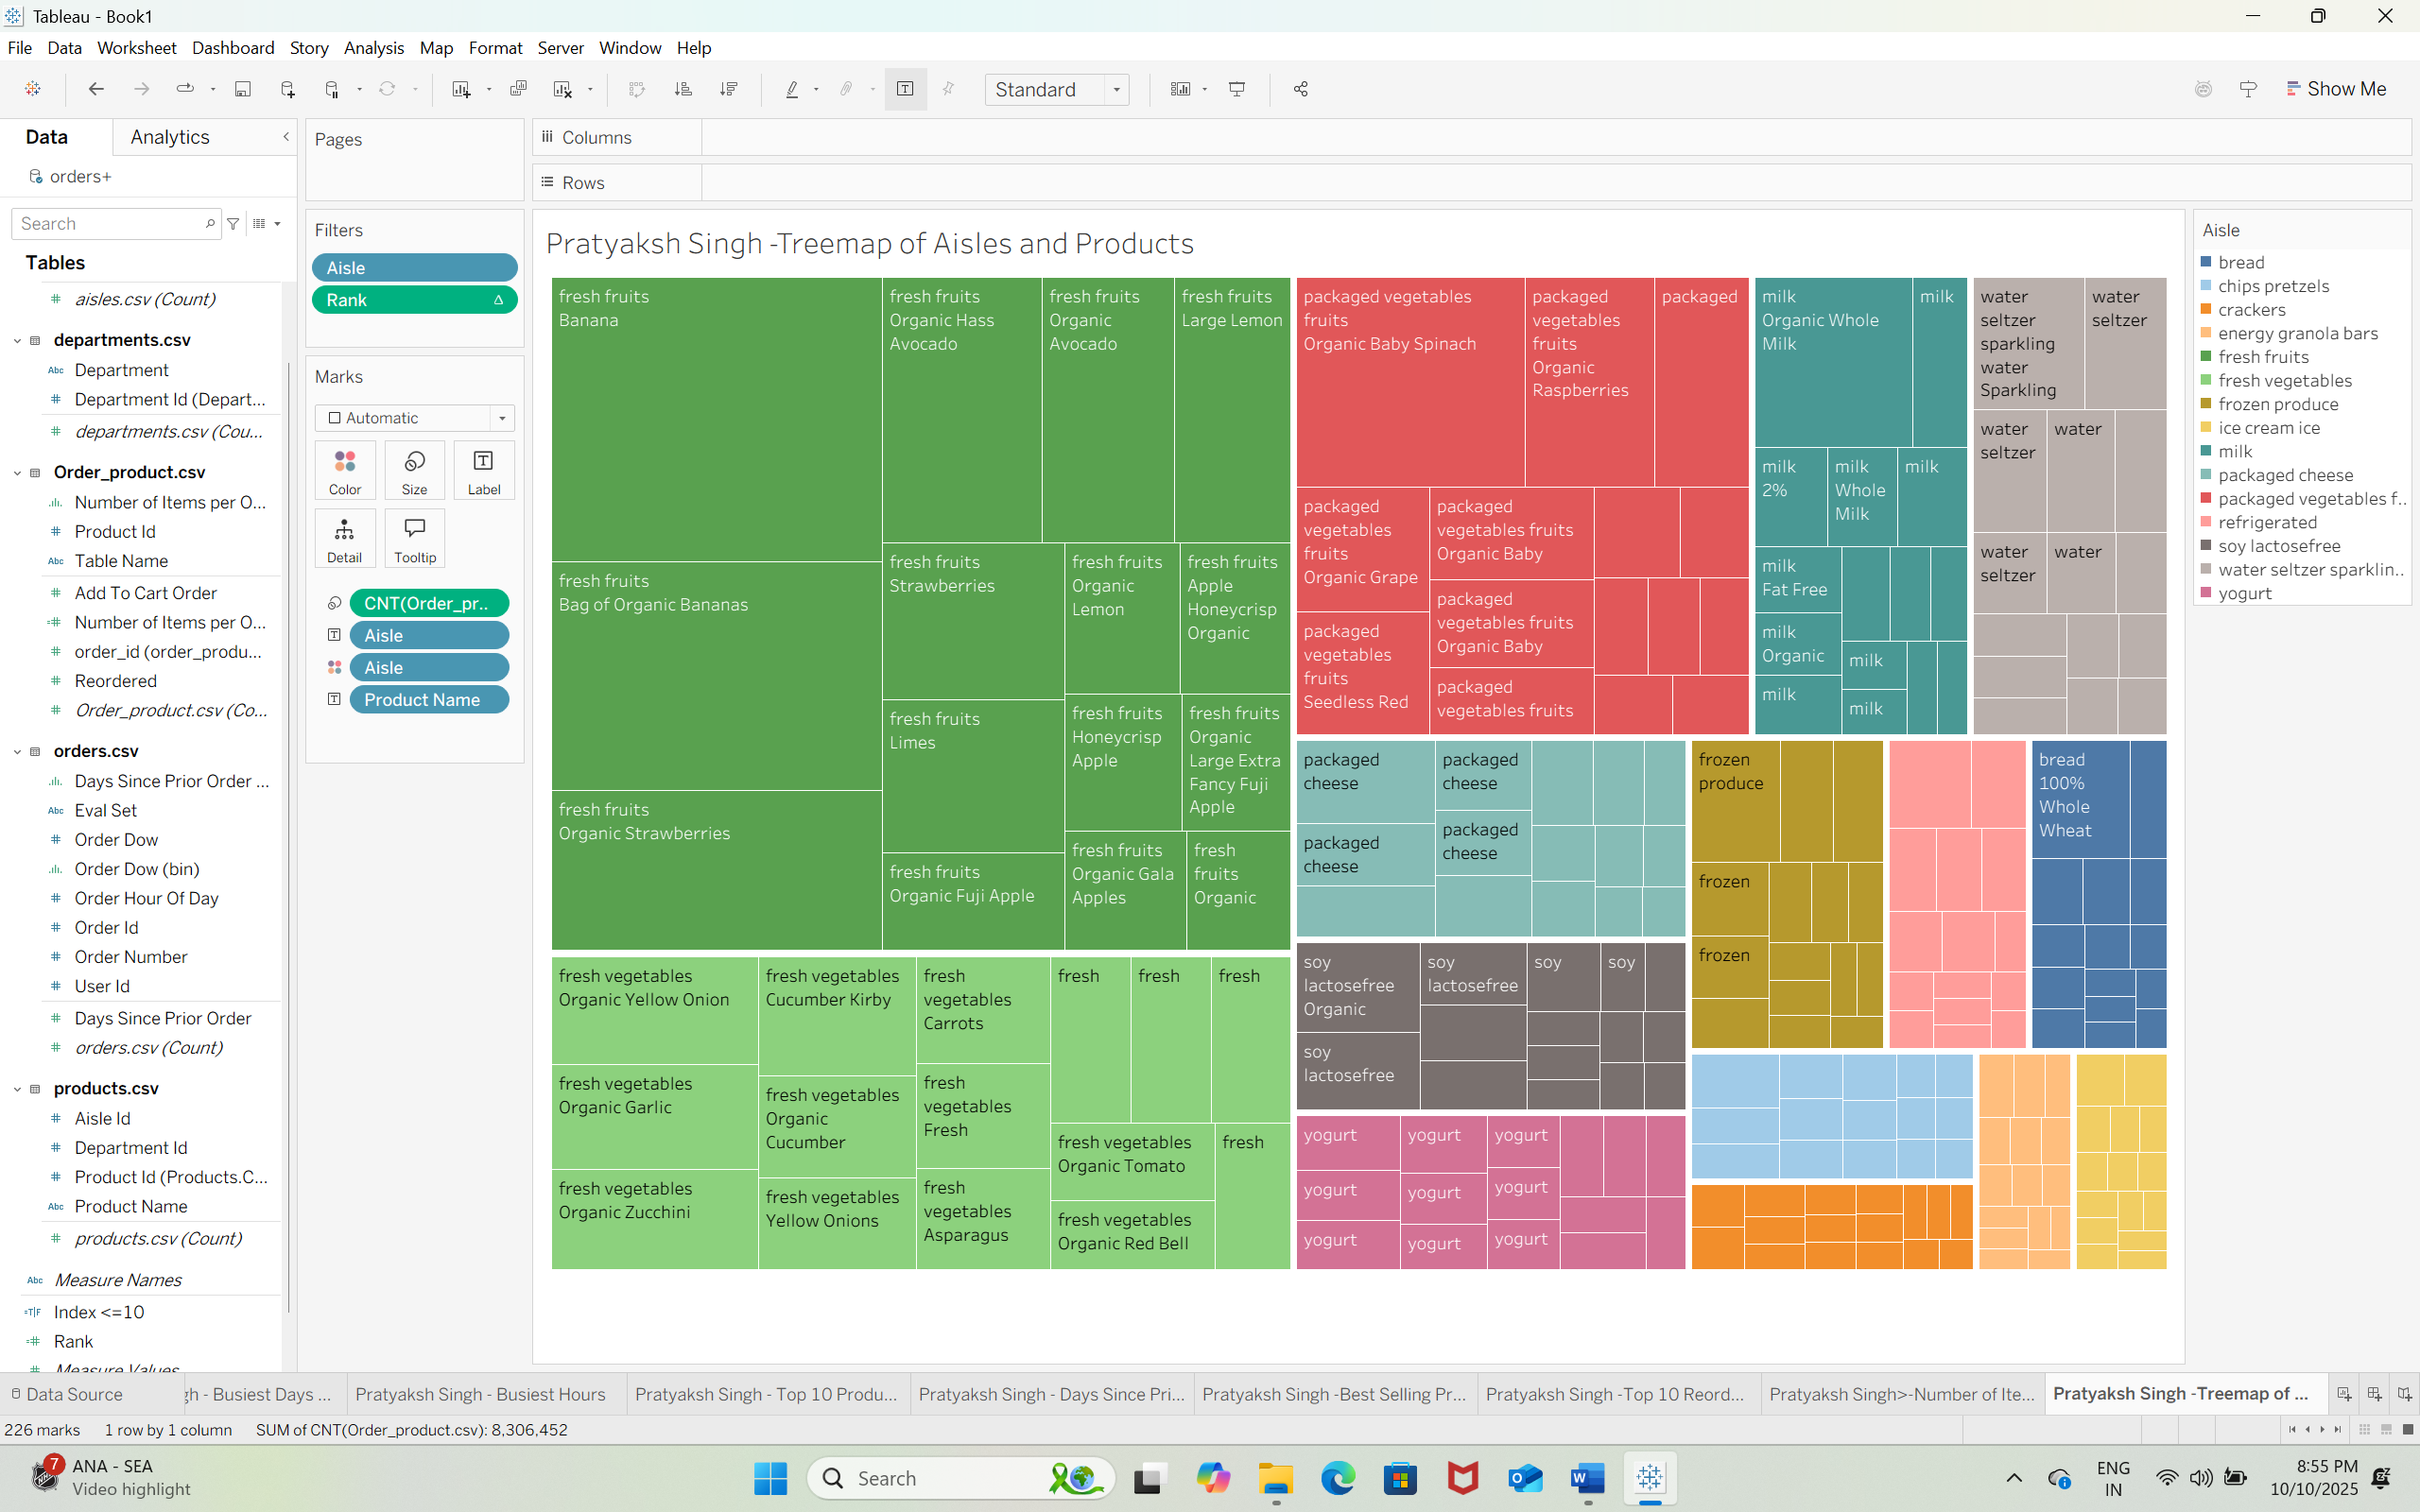  
  
Q27) Top 3 aisles are fresh fruits, fresh vegetables & packaged vegetable fruits.  
Q28)

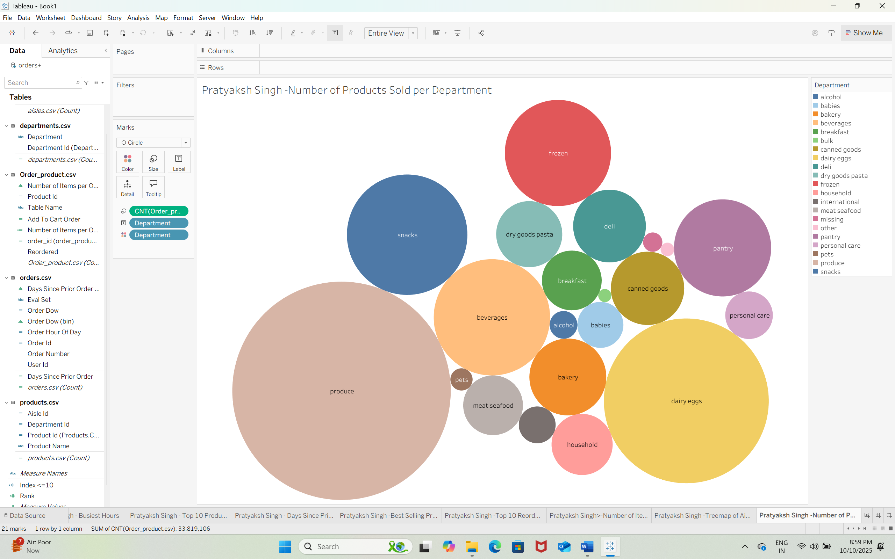  
  
Q29) Top 2 departments are Produce & Dairy Eggs.  
  
Q30)  
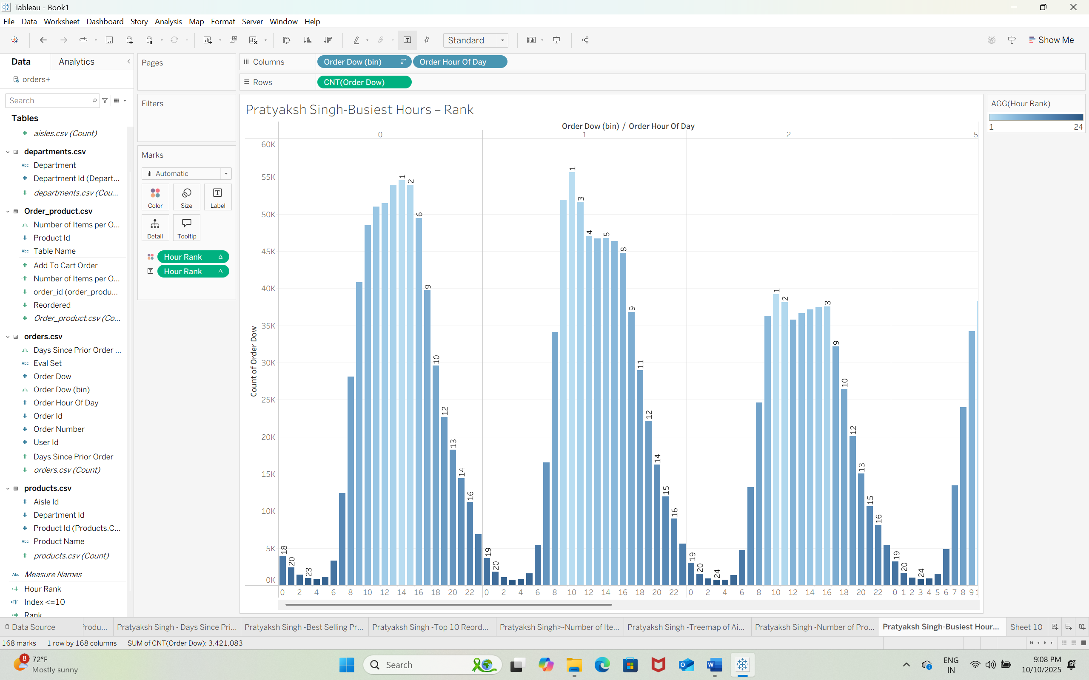  
  
Q31)  
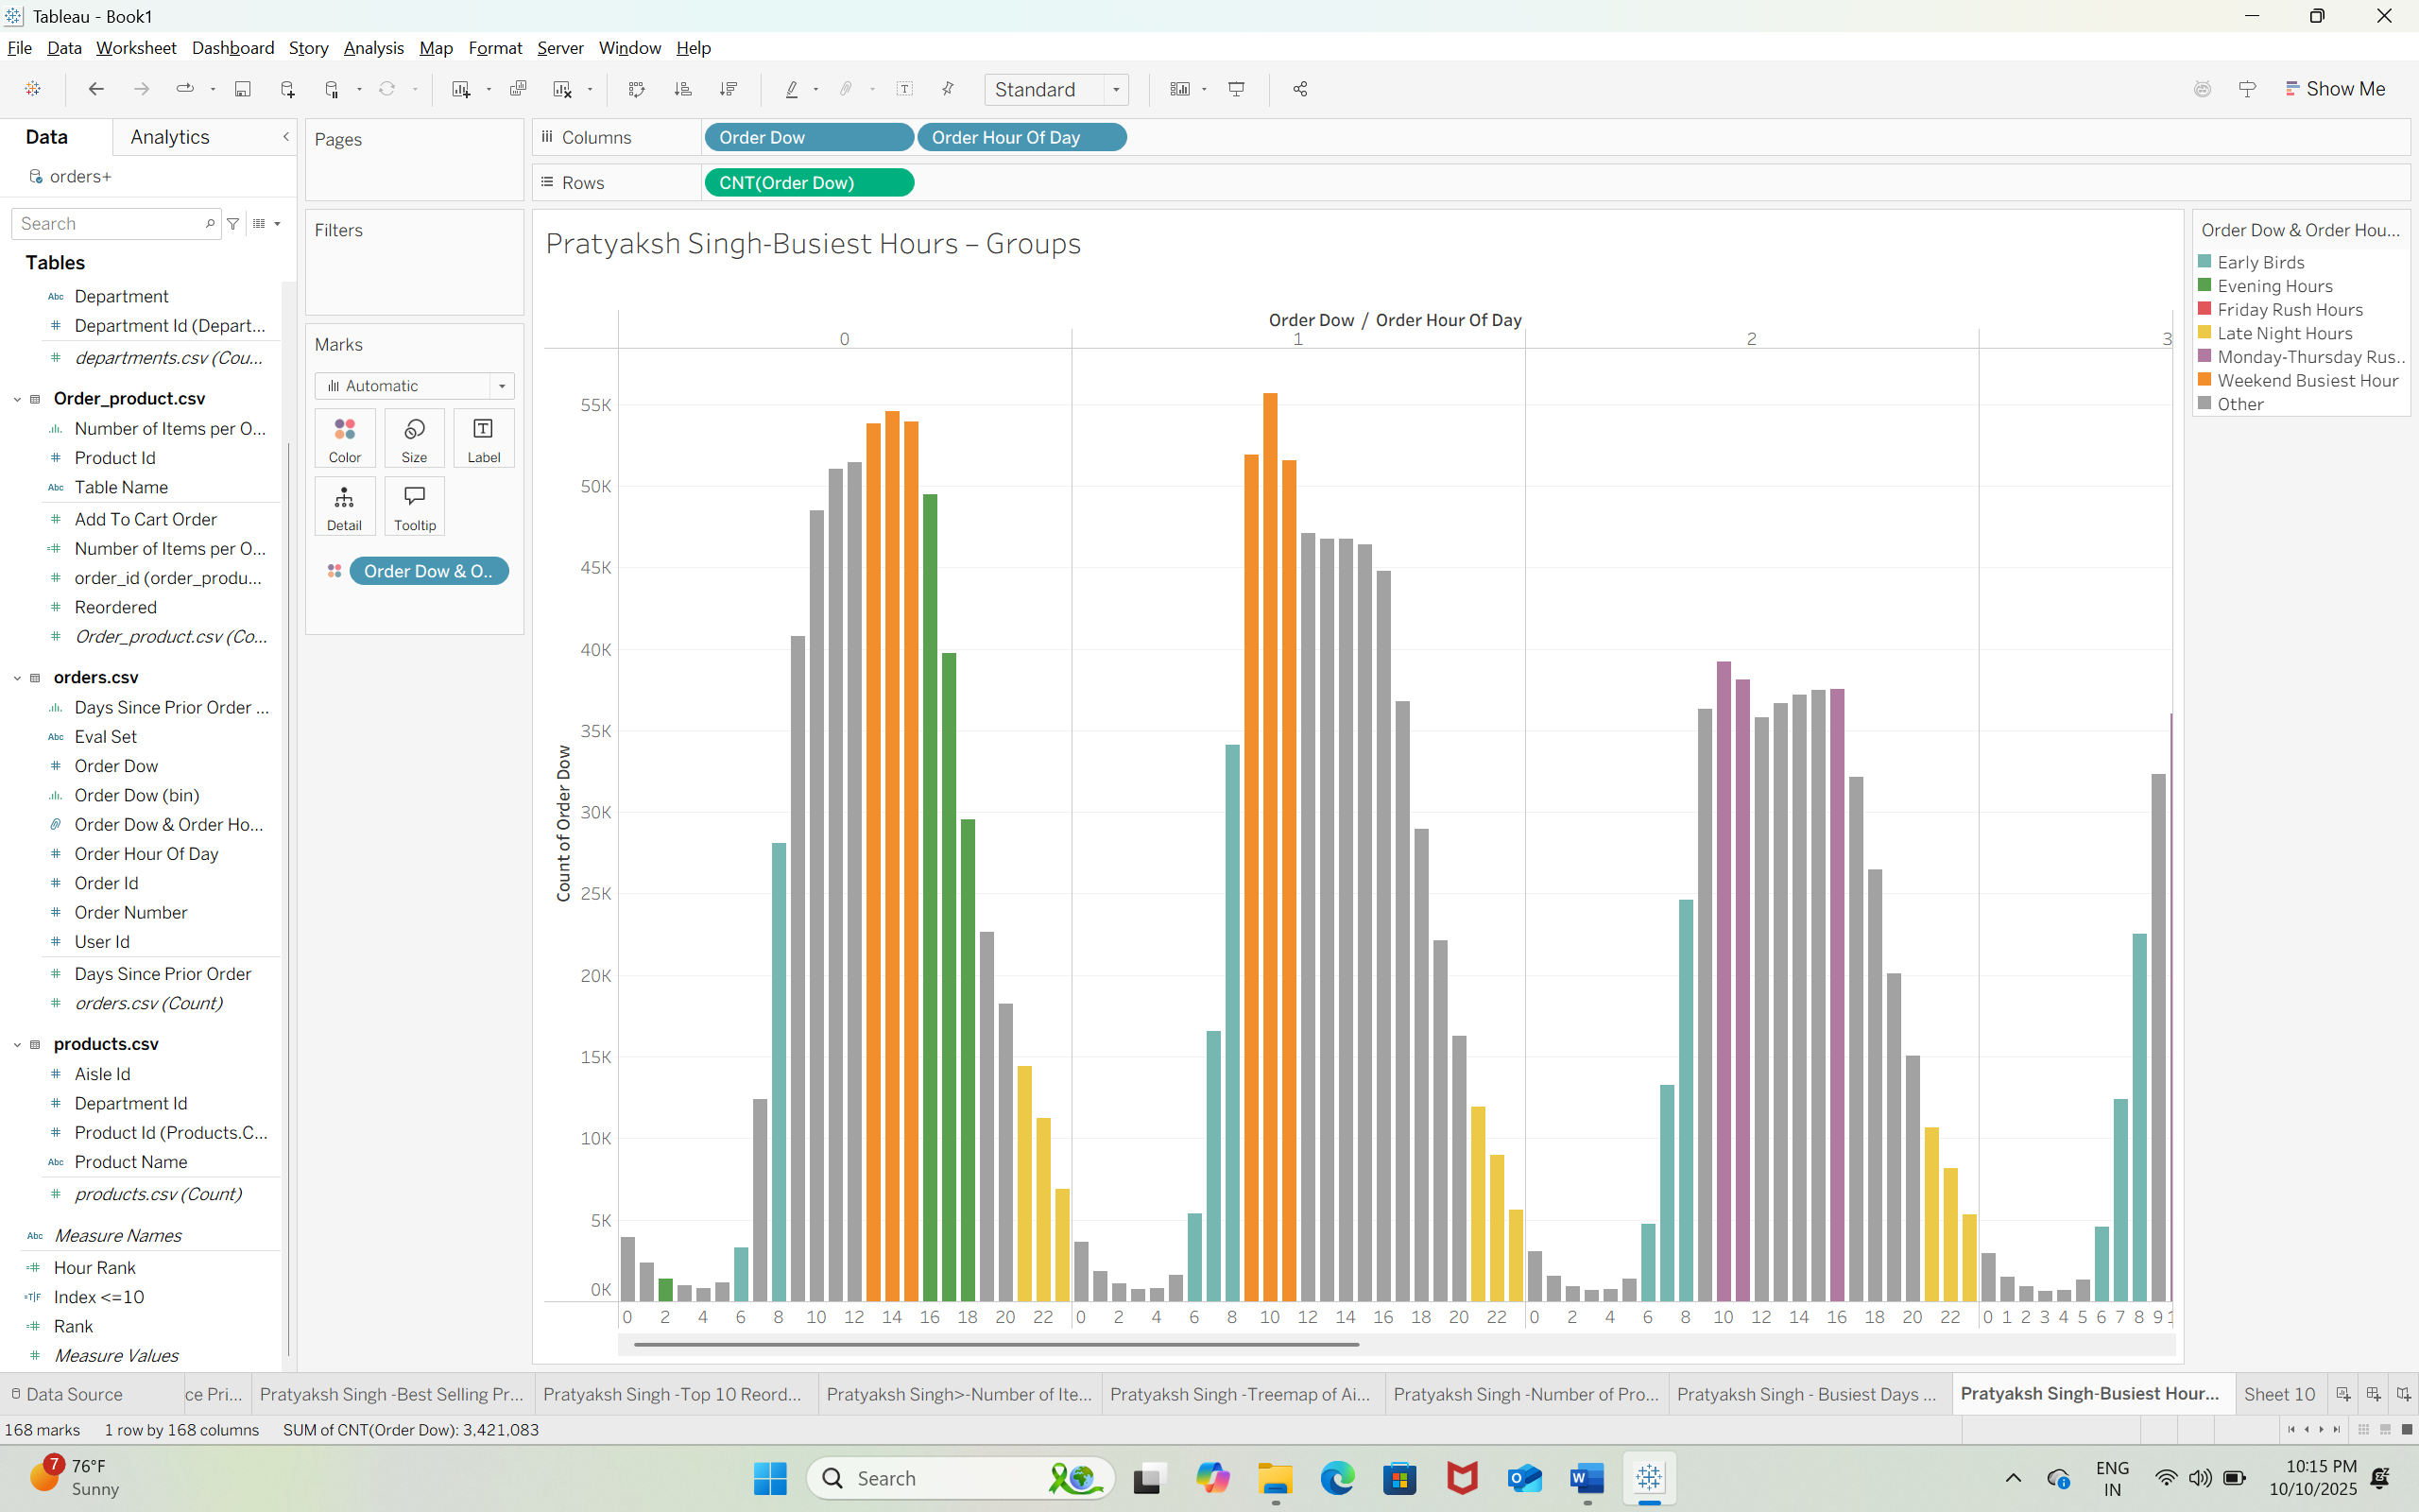Q32)  
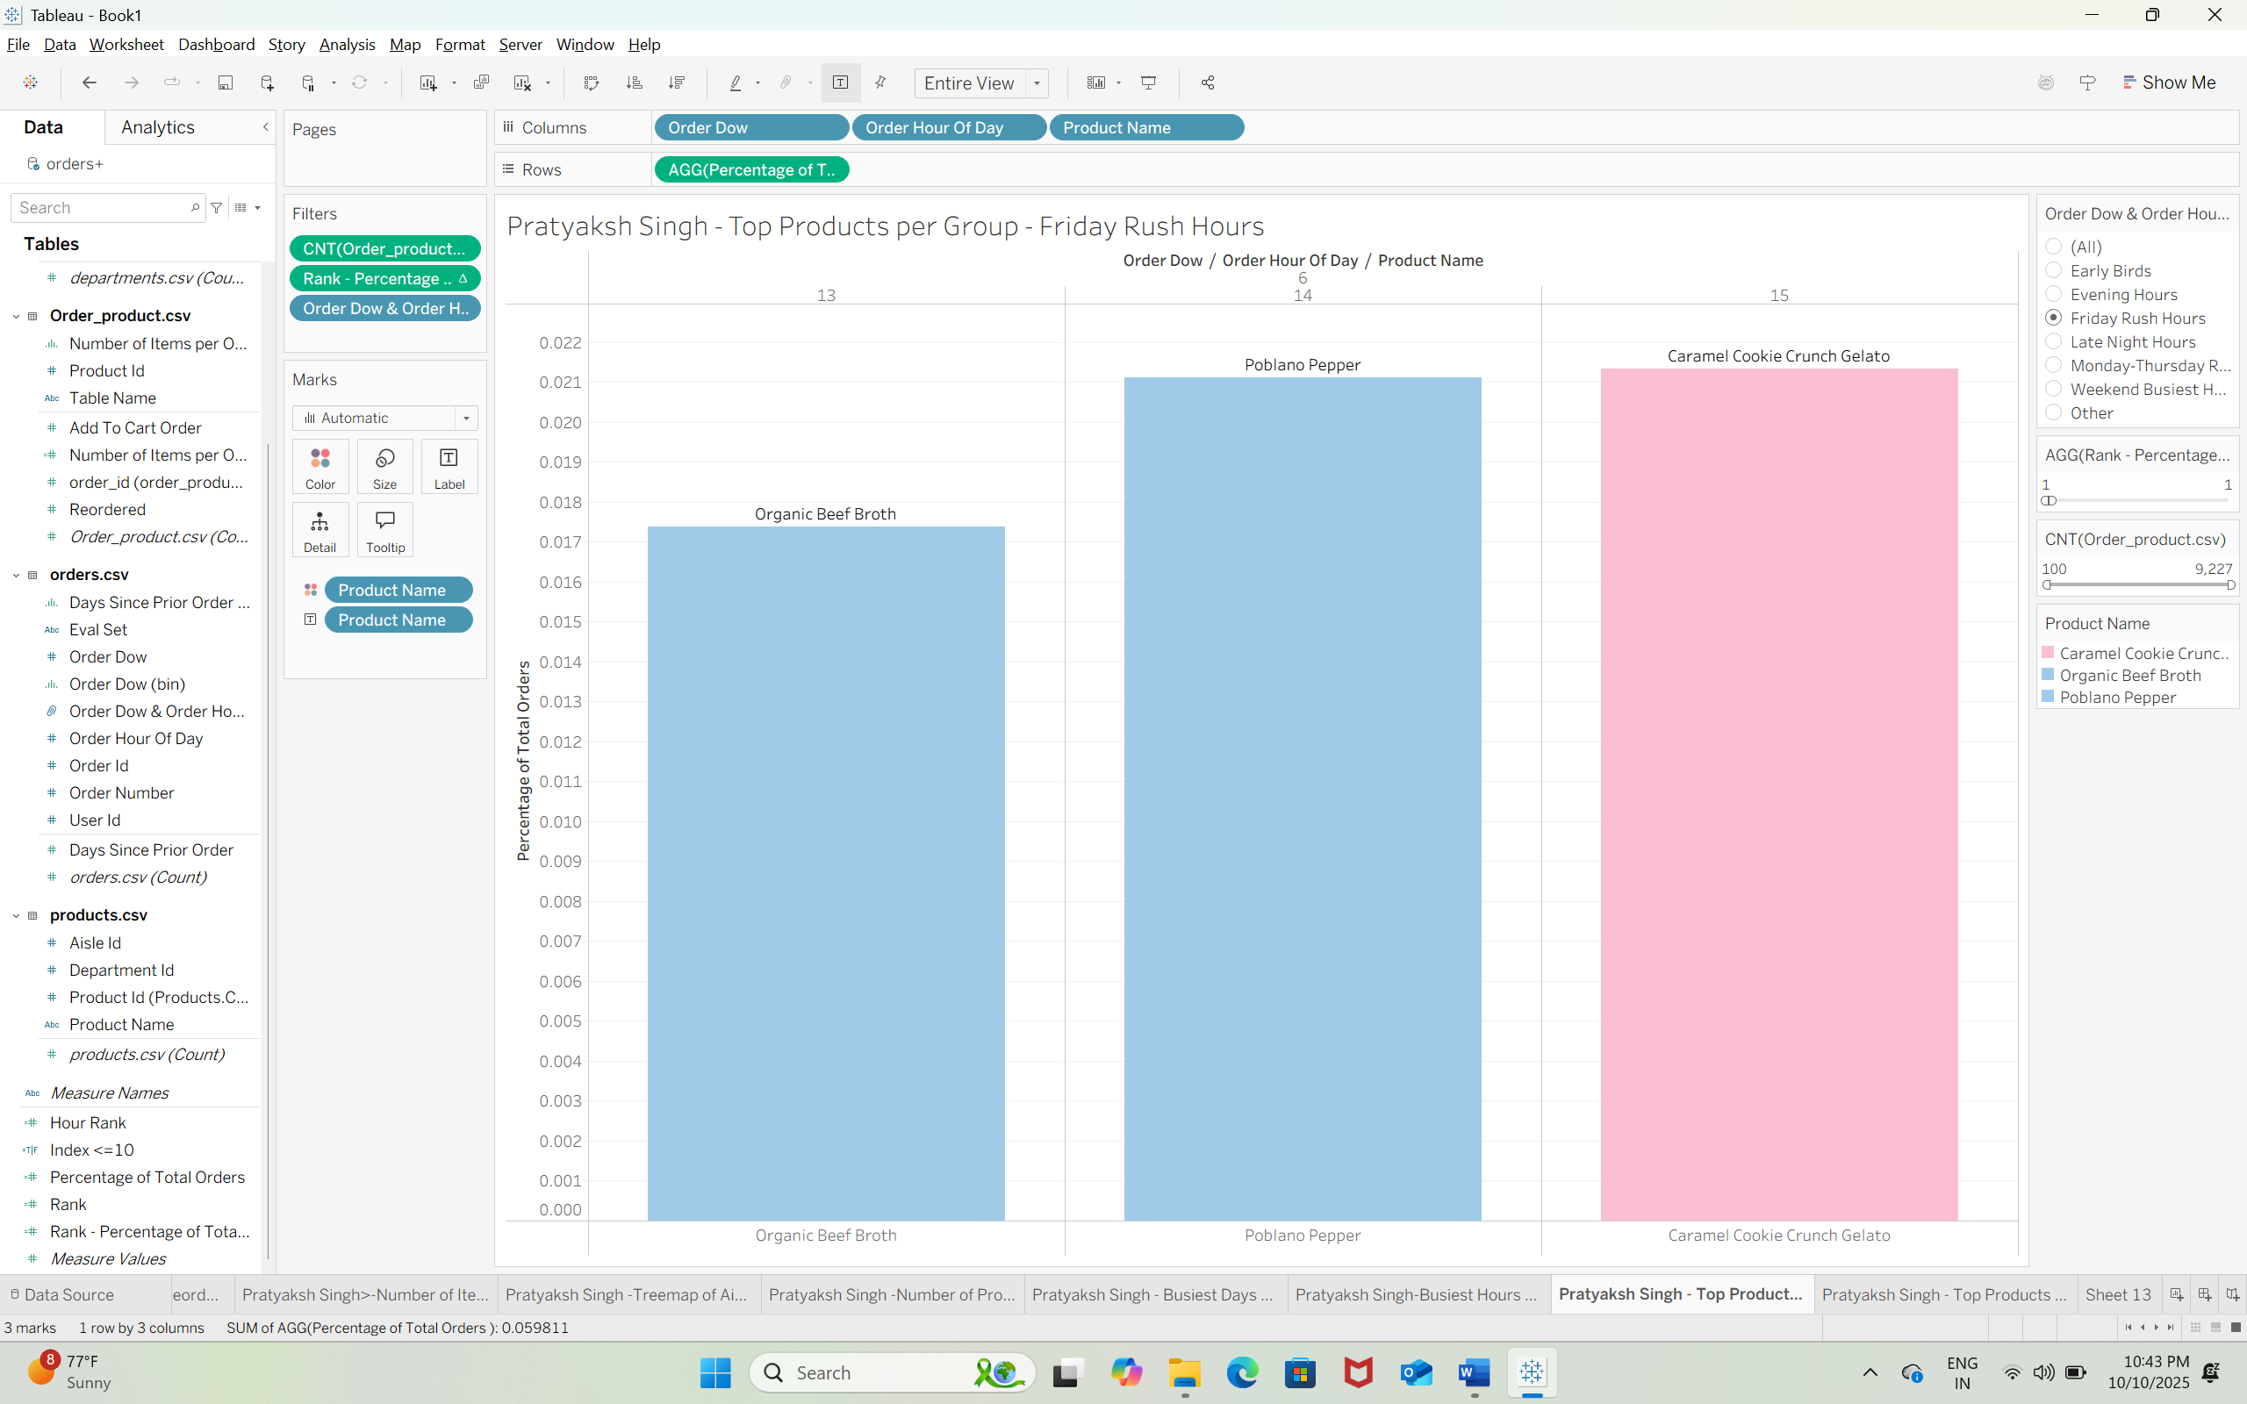  
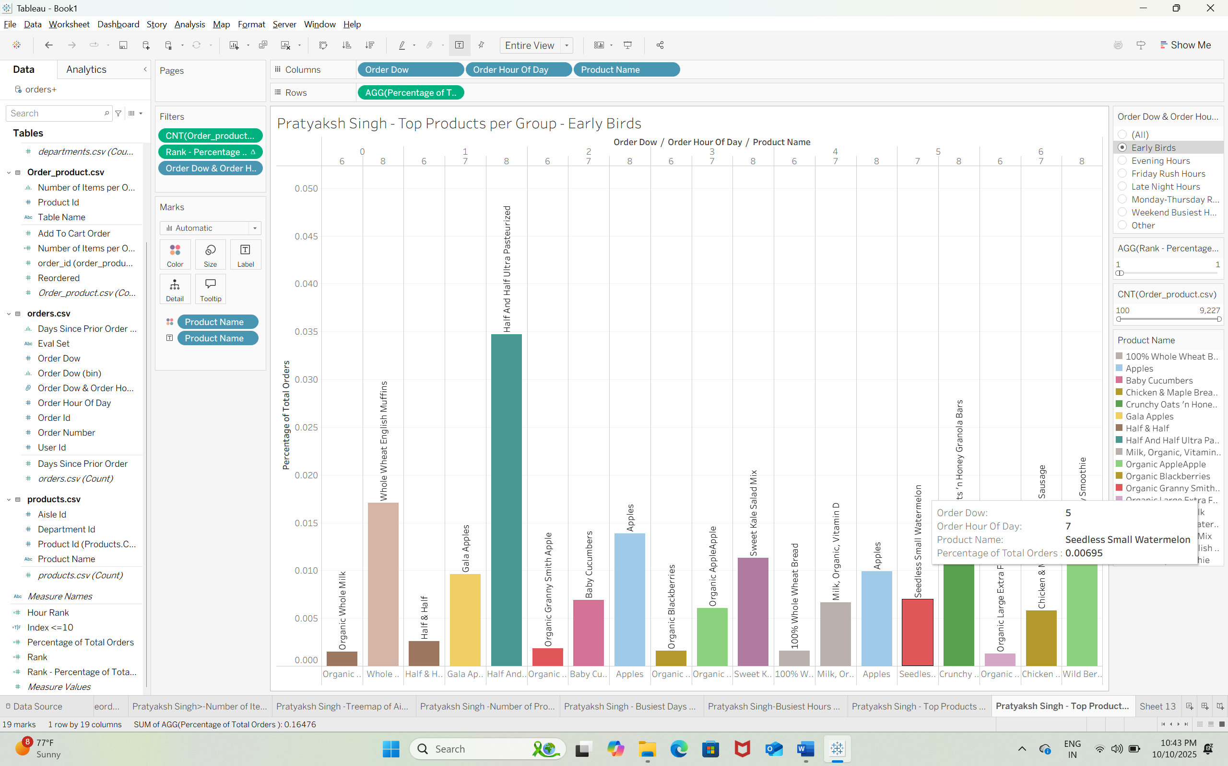 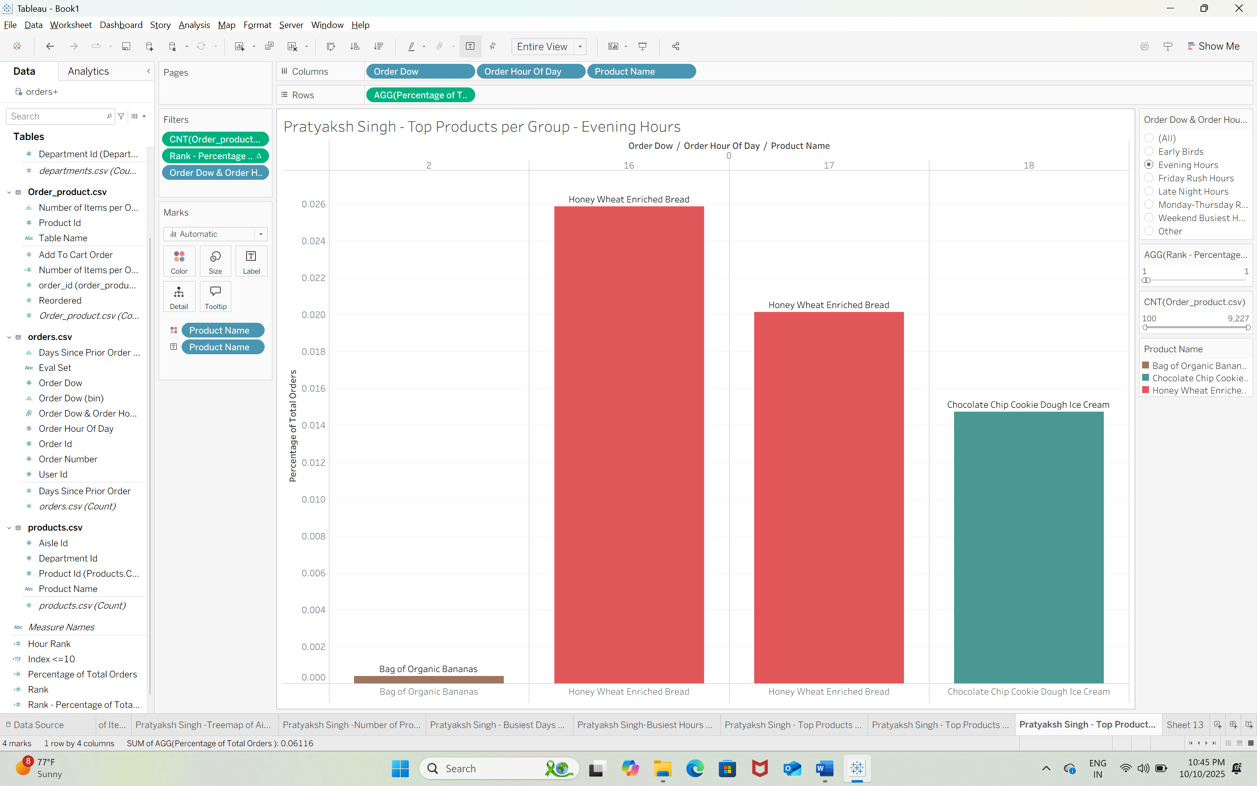 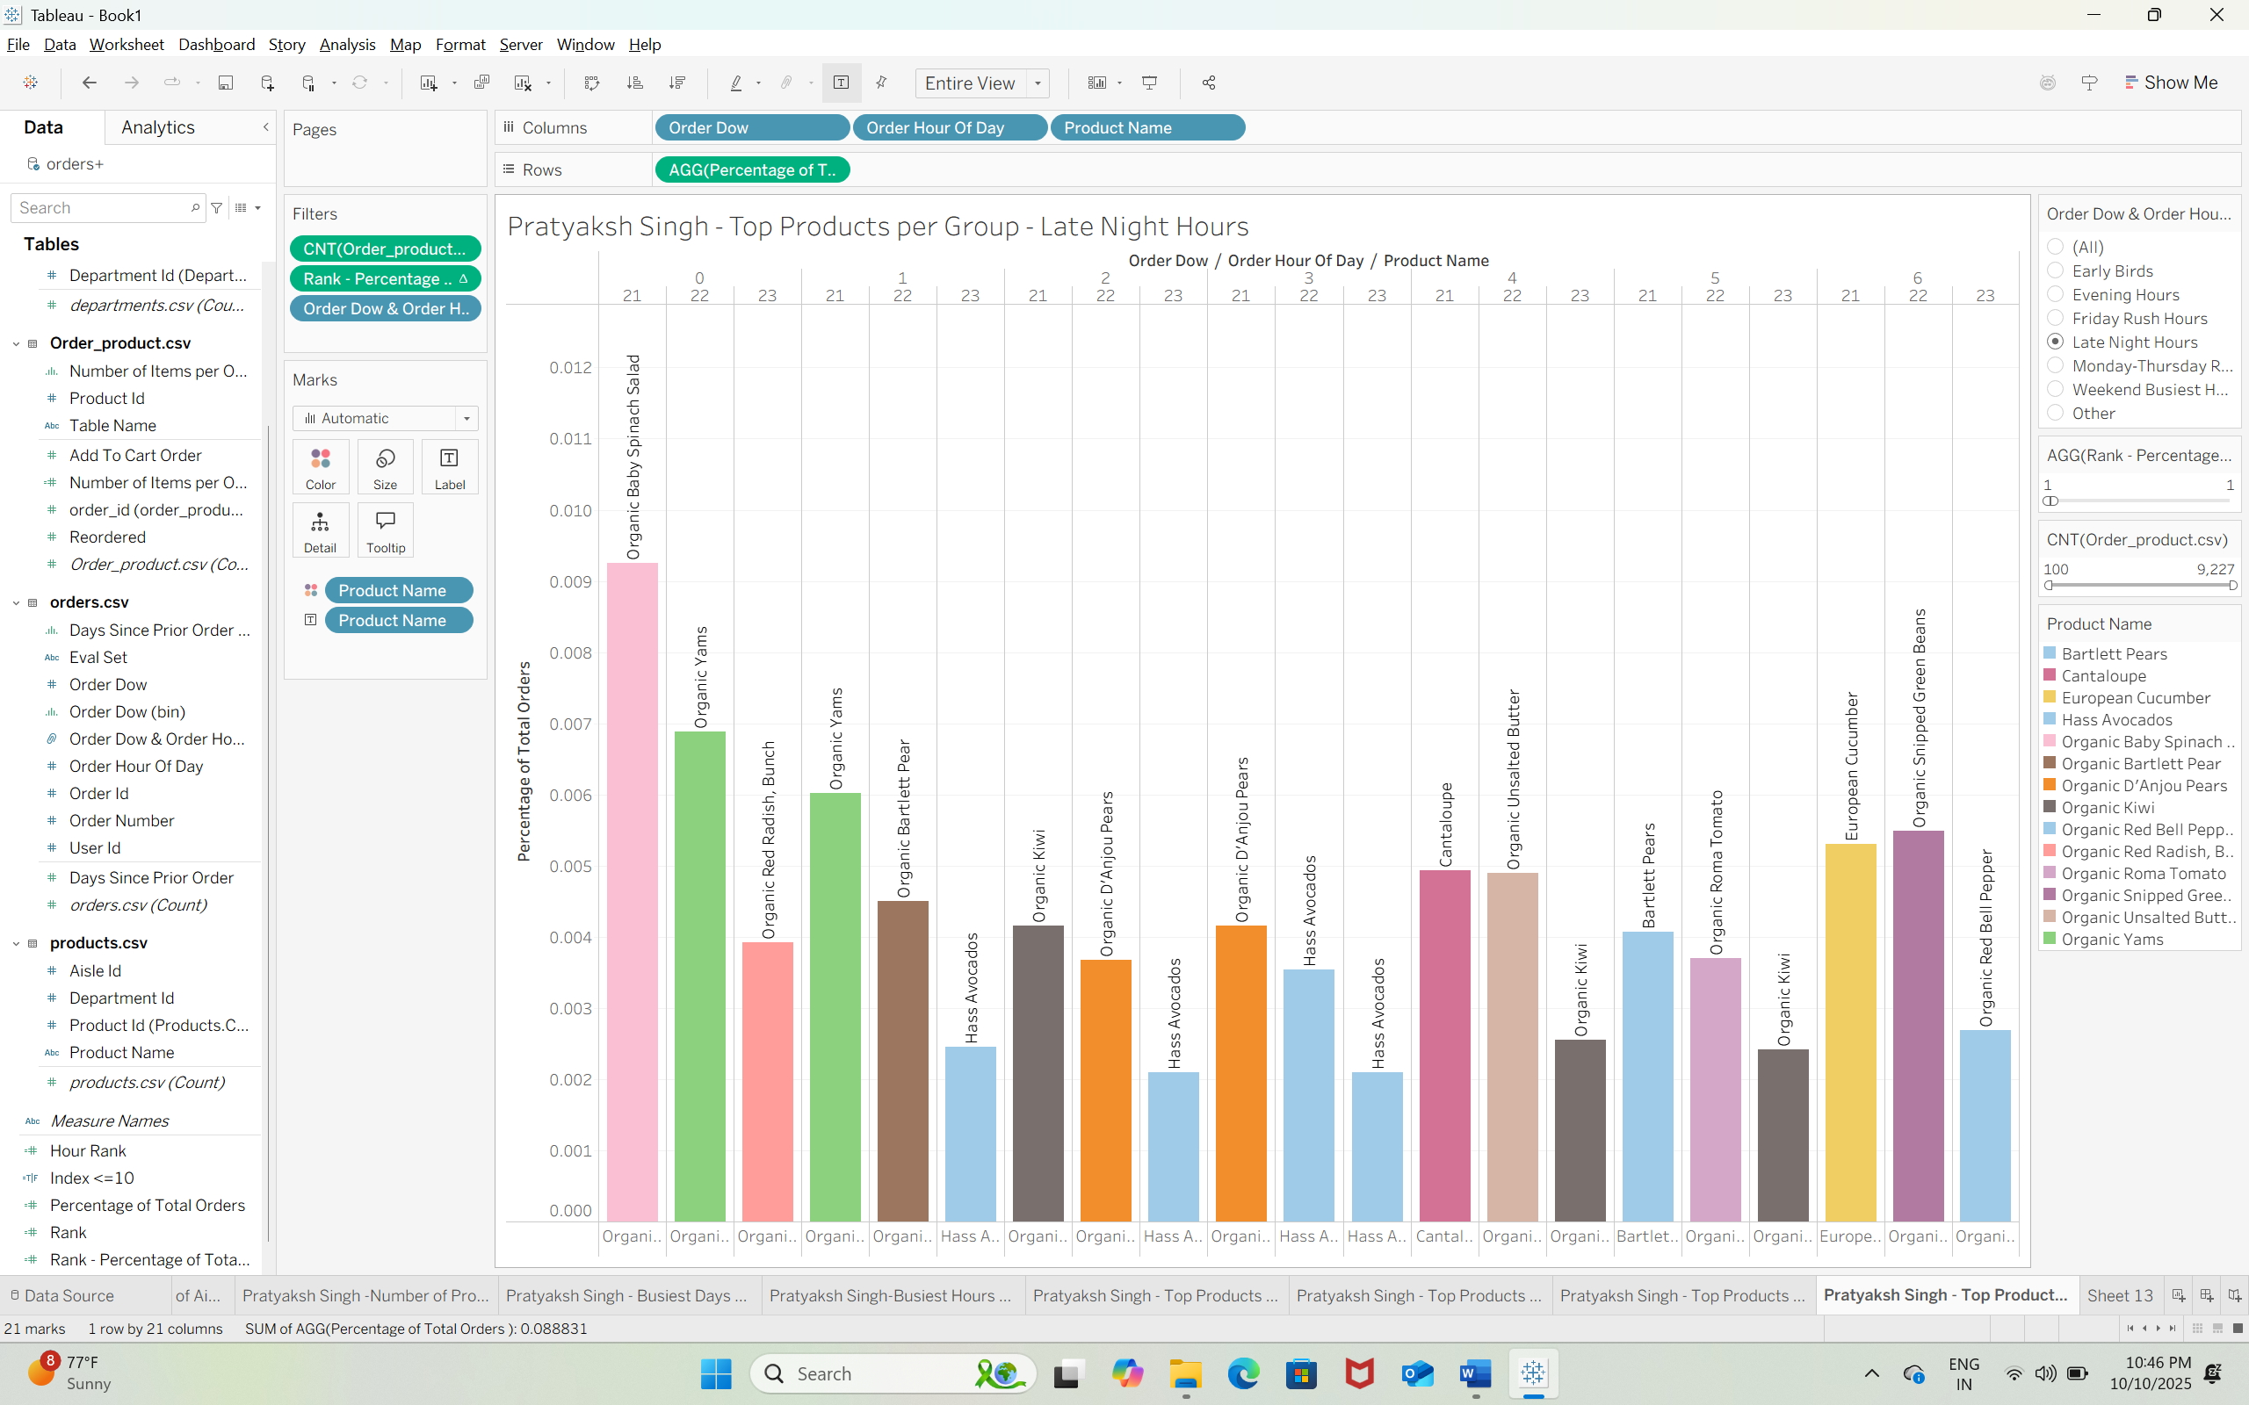 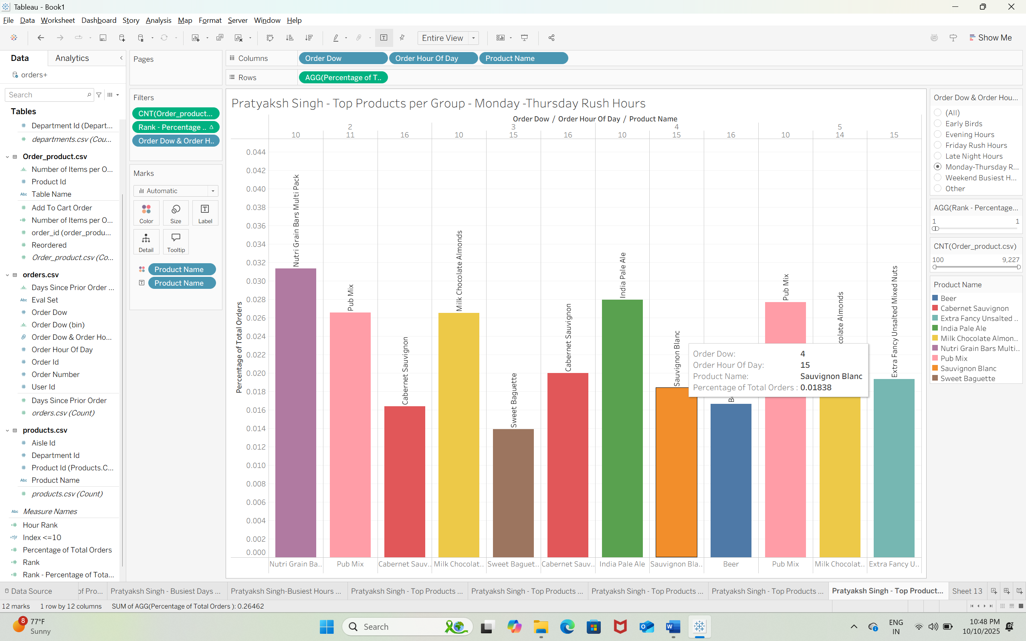 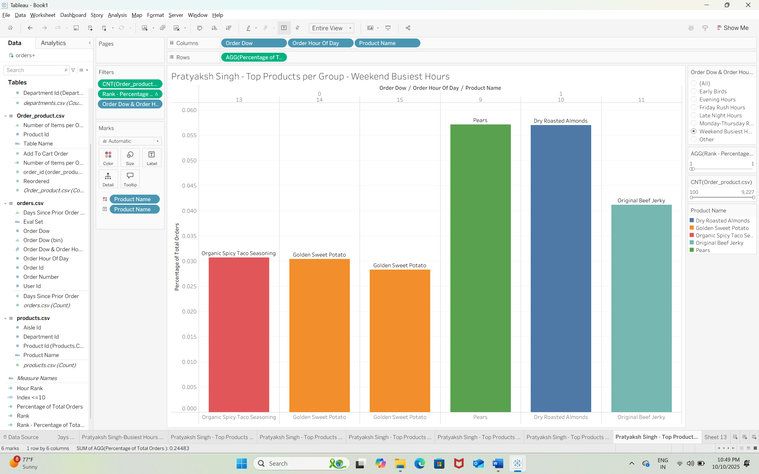  
Q33)  
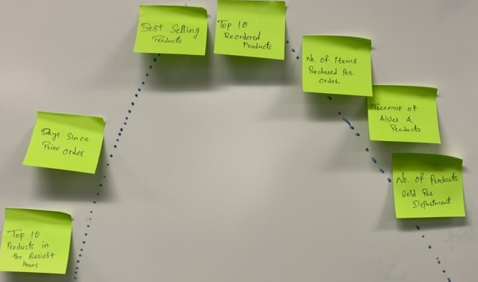  
  
Q34)  
Freytag Pyramid

Busiest Days of the Week – Exposition

Busiest Hours – Exposition

Top 10 Products in the Busiest Hours – Rising Action

Days Since Prior Order – Rising Action

Best Selling Products – Climax

Top 10 Reordered Products – Climax

Number of Items Purchased per Order – Falling Action

Treemap of Aisles and Products – Falling Action

Number of Products Sold per Department – Falling Action

Busiest Hours - Rank – Falling Action

Busiest Hours - Groups – Falling Action

Top Products per Group

Q35) The best type of rhetoric for this story is Logical Rhetoric.  
Q36)

* Busiest Days of the Week – "Peak days ignite our collective rhythm."
* Busiest Hours – "Time races as energy floods the floor."
* Top 10 Products in the Busiest Hours – "In the rush, our champions rise."
* Days Since Prior Order – "Every delay echoes lost momentum."
* Best Selling Products – "Our icons define the marketplace pulse."
* Top 10 Reordered Products – "Loyal favorites that customers can’t resist."
* Number of Items Purchased per Order – "Each cart narrates a story of need and desire."
* Treemap of Aisles and Products – "A living canvas of our shopping heartbeat."
* Number of Products Sold per Department – "Departments drum with consistent triumphs."
* Busiest Hours - Rank – "Power hours rise to dominate the day."
* Busiest Hours - Groups – "Clusters of time reveal hidden potential."
* Top Products per Group - Friday Rush Hours – "Fridays blaze with anticipation and motion."
* Top Products per Group - Early Birds – "Morning sparks promise and fresh ambition."
* Top Products per Group - Evening Hours – "Dusk settles with comfort in every choice."
* Top Products per Group - Late Night Hours – "Midnight cravings awaken bold indulgence."
* Top Products per Group - Monday - Thursday Rush Hours – "Midweek flow fuels consistency and drive."
* Top Products per Group - Weekend Busiest Hours – "Weekends erupt with excitement and demand."

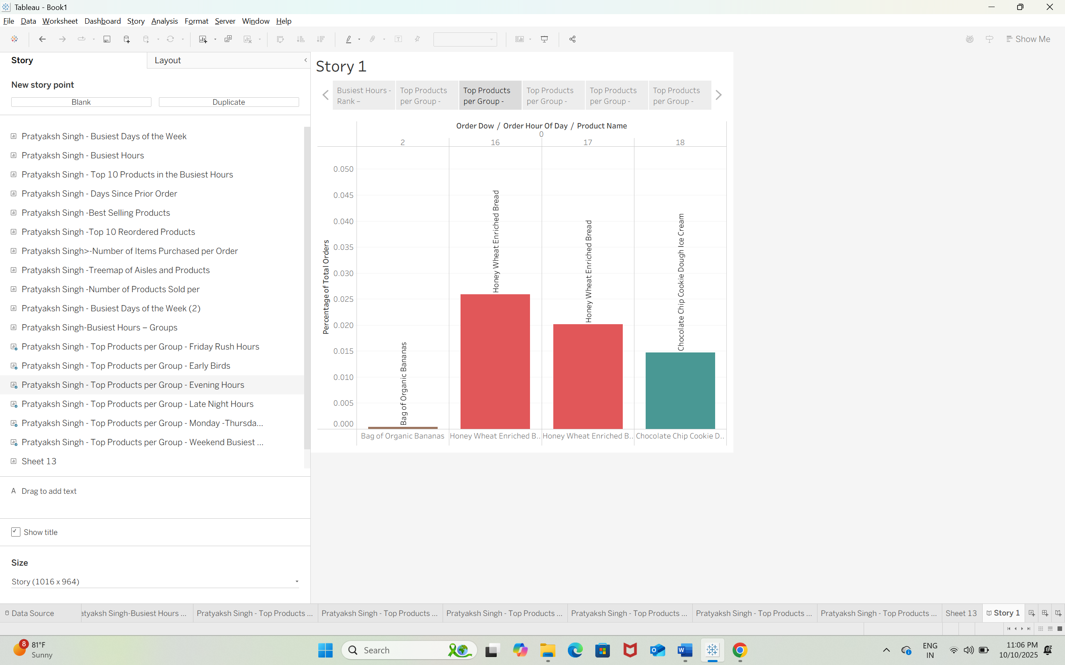 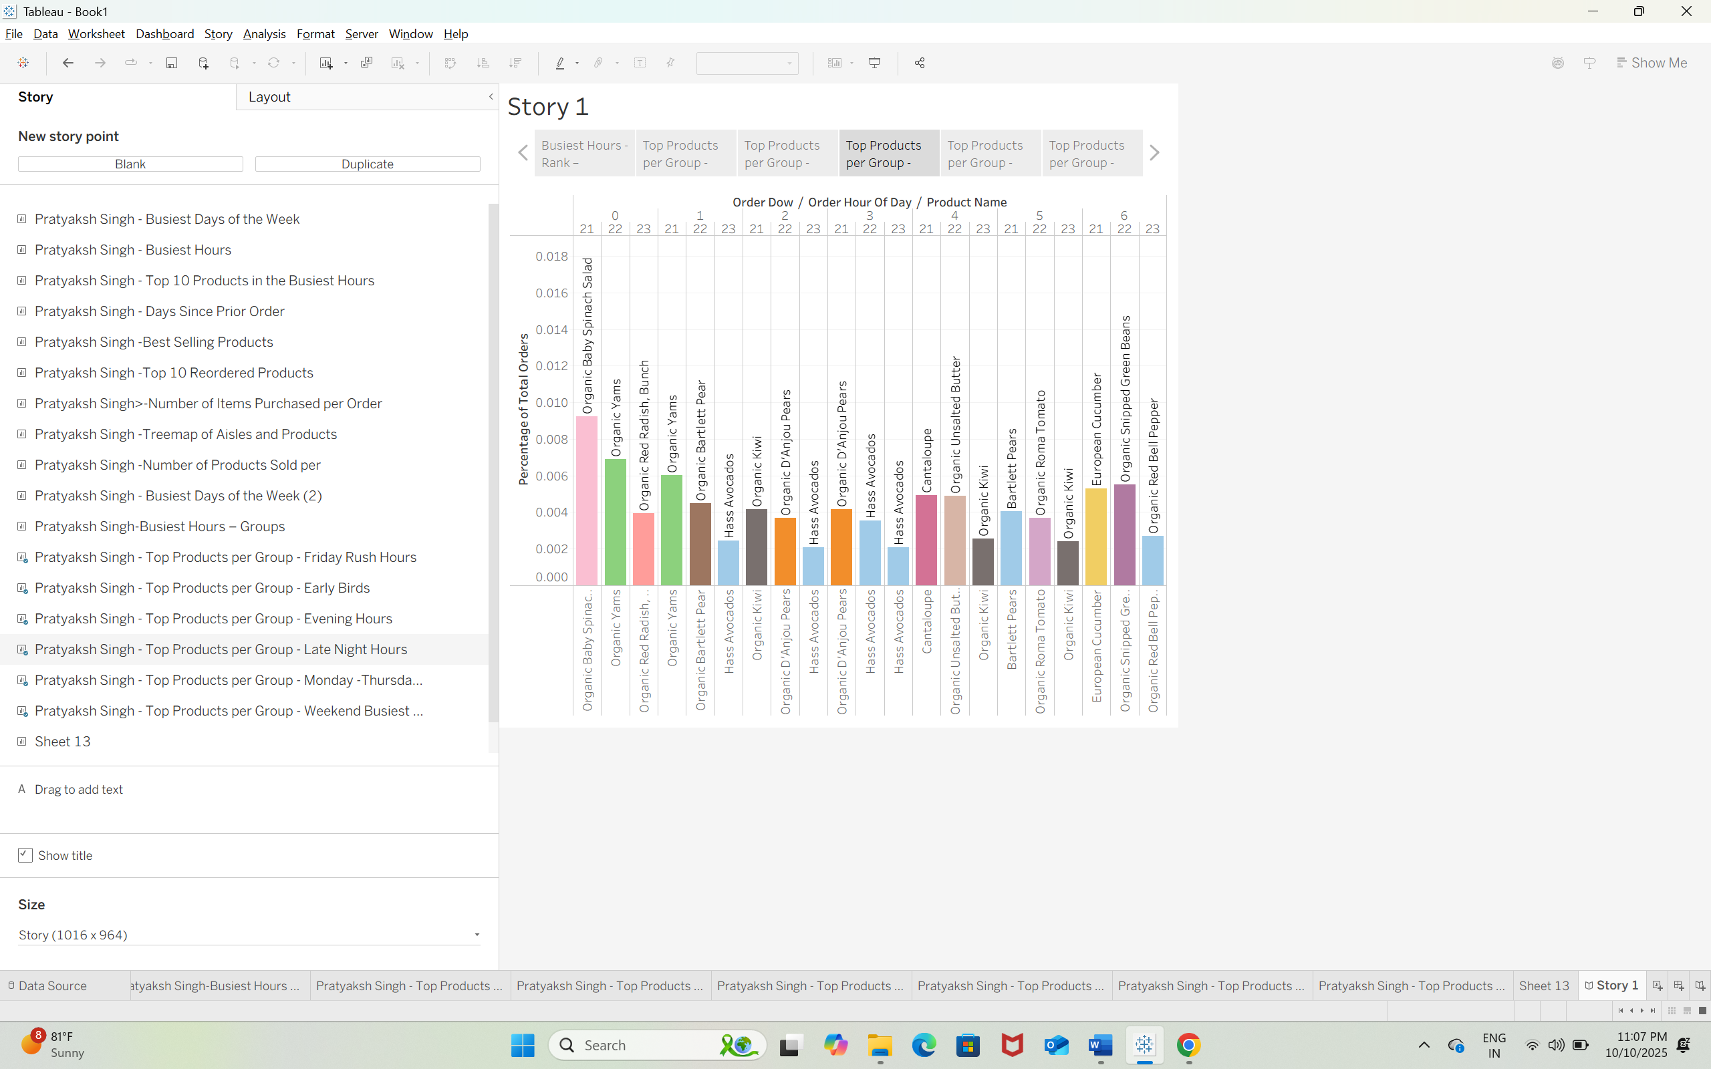 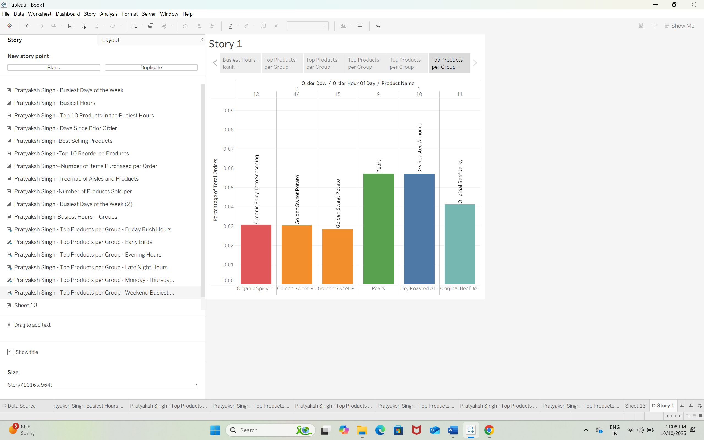  
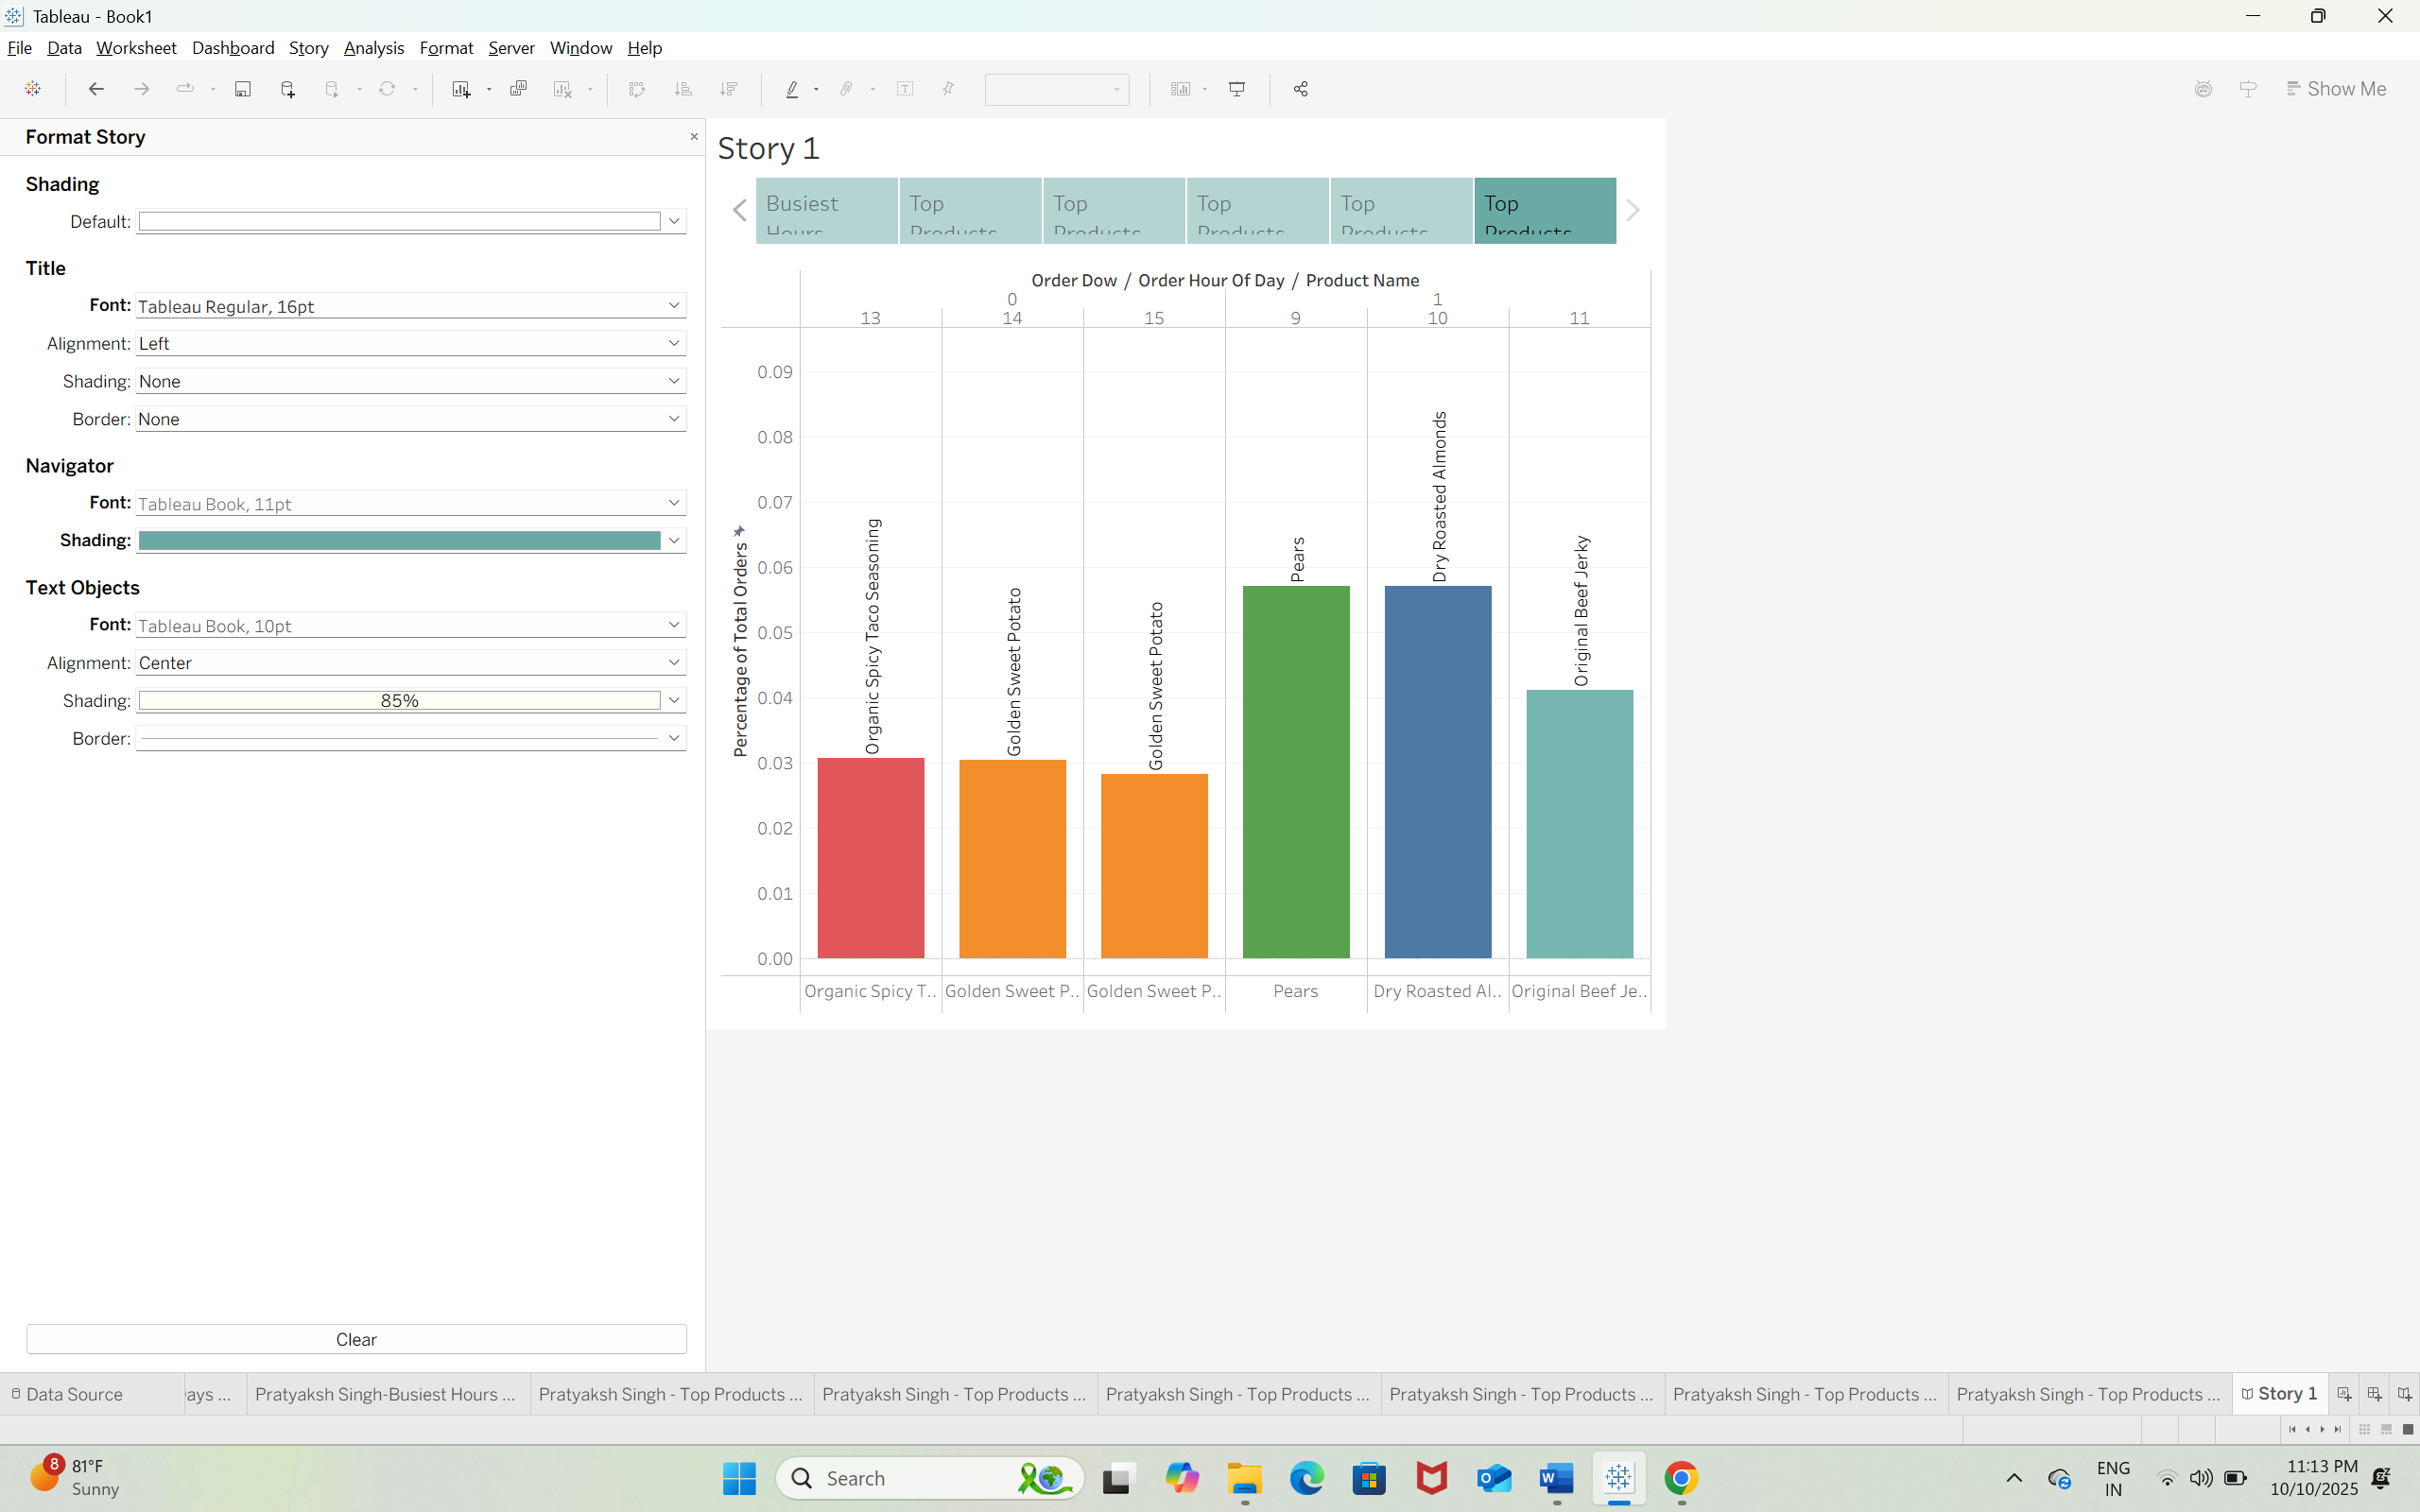  
Q37)  
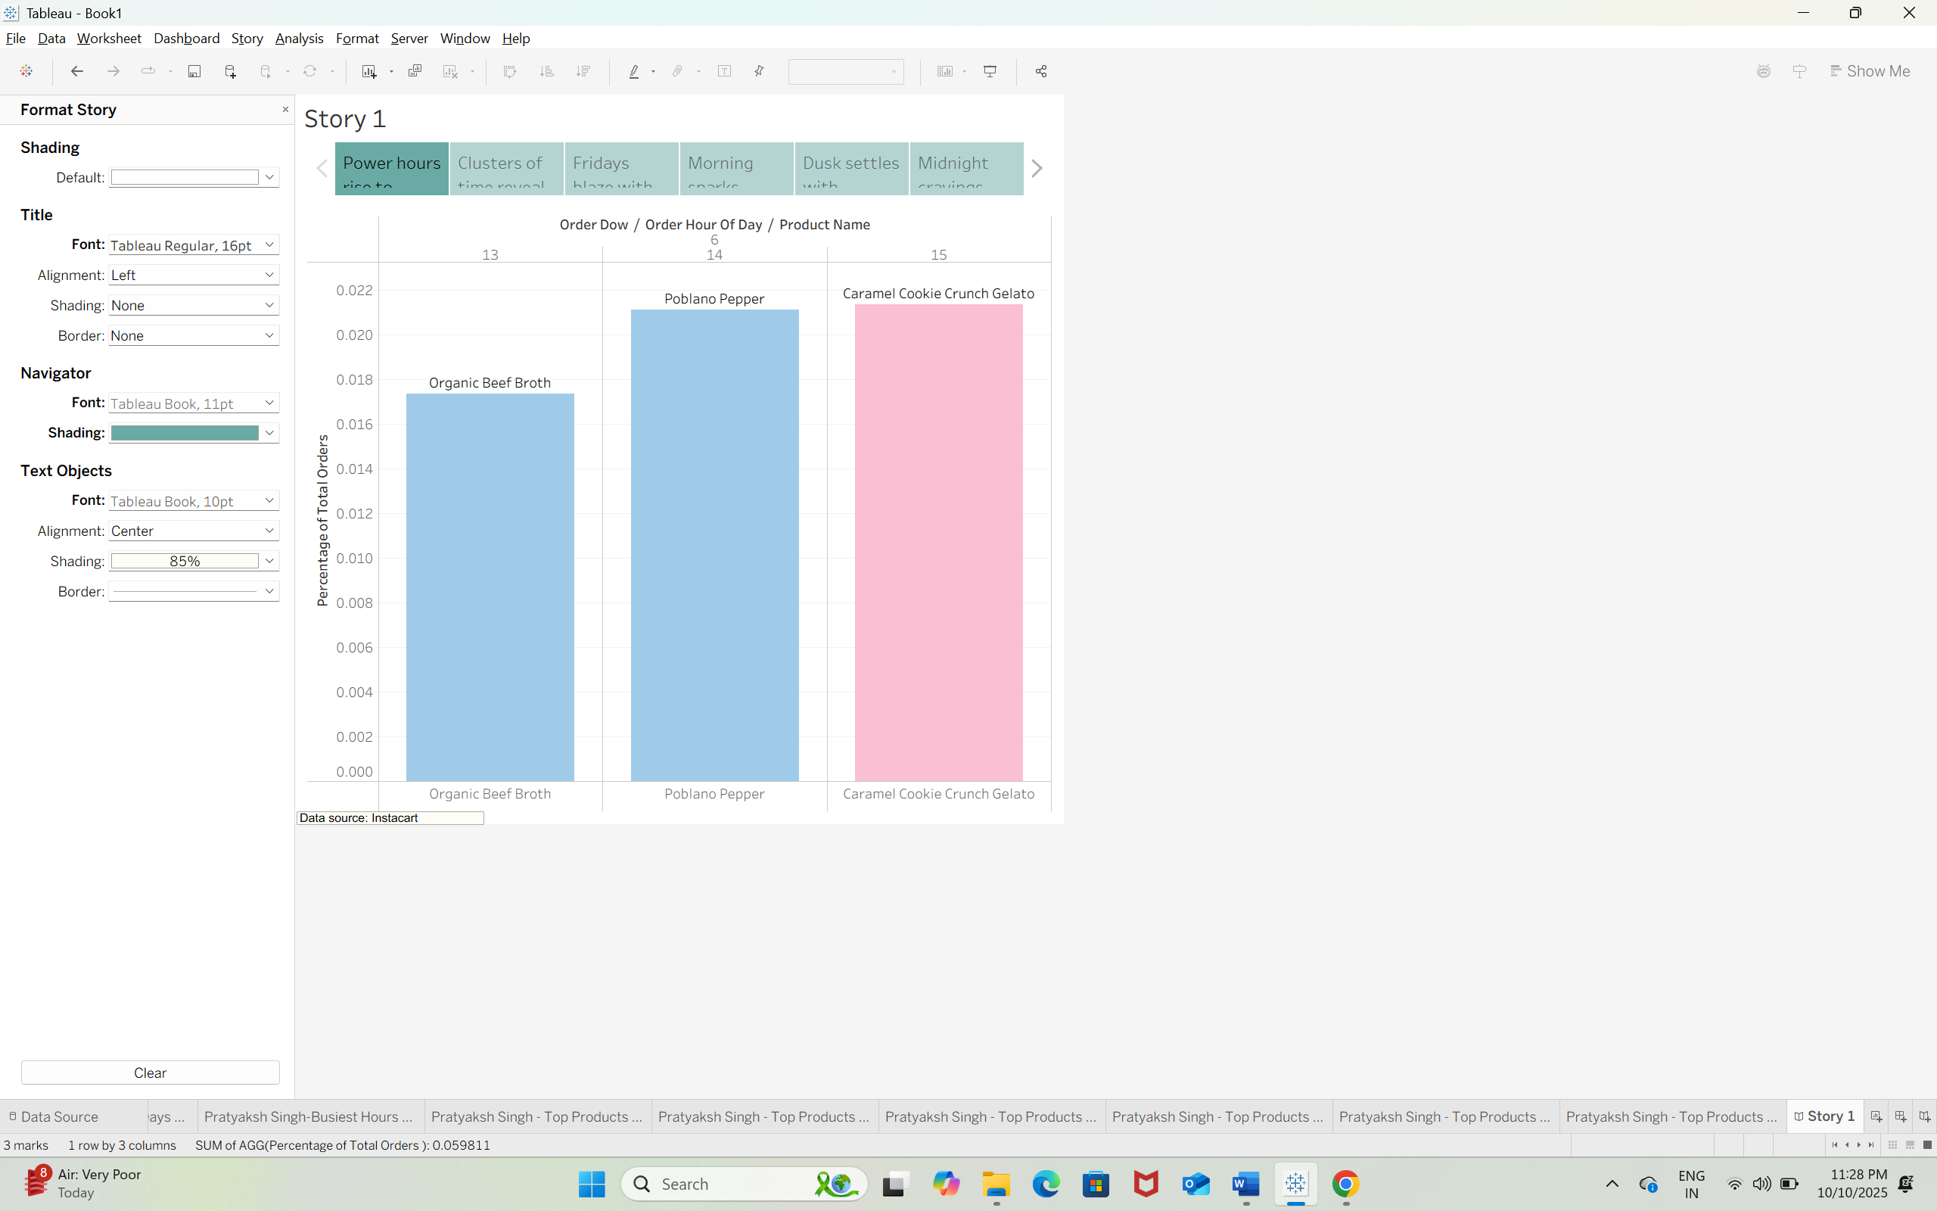  
Q38)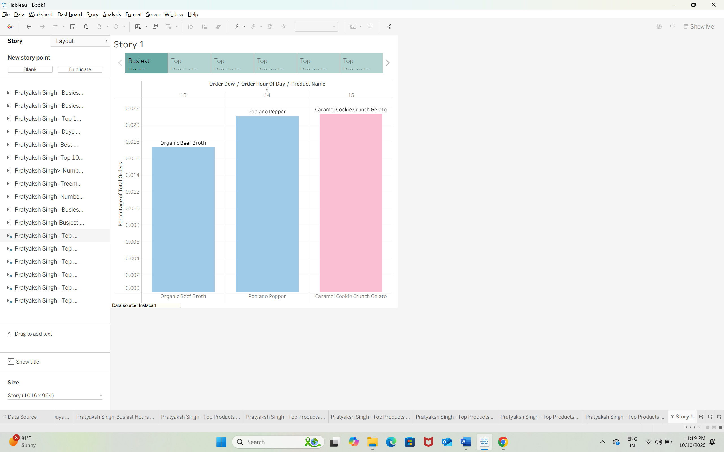  
Q39)  
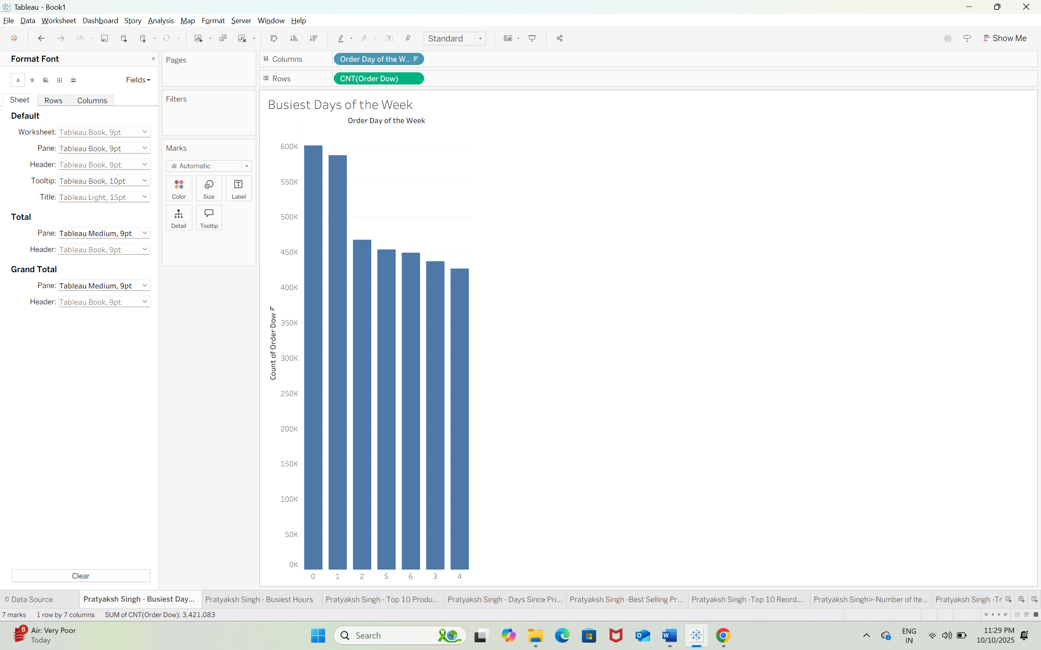  
Q40)  
